**Executive Summary**

|  |  |
| --- | --- |
| **Analysis of Bike Sharing Dataset** | **MIS 6324.0W1 TERM PAPER- REPORT** |

Under the Guidance of:-

**Dr. Syam Menon**

Through this project, we got an opportunity to apply data mining techniques and processes on a real dataset. It gave us a first-hand experience of working on and understanding a dataset of a company, deliberating on the questions whose answers are needed to enhance the company’s profit and using various data mining methods to answer those questions.

The dataset that we have used for the term paper is ‘*Bike sharing dataset’* of Capital Bikeshare which gives the hourly and daily information of the number of bikes rented by casual and registered users along with environmental, seasonal and other details of the hour or day. Bike Sharing Industry provides a healthy alternative to other conventional modes of transport which have larger environmental footprints. As the industry is still emerging and the Bike-sharing rental process is observed to be highly correlated to the environmental and seasonal settings, it is relevant to study the vast amount of data available on bike sharing to extract important insights that can be used to make business decision with the objective of increasing profit.

The purpose of our term paper was to answer the following questions:-

1. Do the temperature factors have an impact on the renting of bikes by casual users?
2. Do the temperature factors have an impact on the renting of bikes by registered users?
3. Is there more rental activities in certain combinations of weather conditions than others?
4. Whether a given day would be profitable for the Bike Share company/system based on information like environmental parameters, whether it is a working day or a holiday, the month etc?

To answer the first 2 questions, we applied Linear Multiple Regression technique to find relationships between the various weather factors and the number of bikes rented by casual users and registered users respectively. We also compared the regression results for both types of users to determine if both the user groups are similarly affected by weather parameters.

We have then tried to answer the 3rd question by clustering the data containing the weather parameter variables and used techniques like segment profiling and graphs to find a pattern in the clusters with respect to the profit the company/system is making during those hours.

We then applied various predictive techniques like Decision tree, Interactive Decision Tree and Logistic Regression to build models that would predict the profitability level (‘profitable’ or ‘not profitable’) of the Bike Sharing company on a given day, given various environmental and seasonal factors as inputs.

For each of the above mentioned sections, we have described the pre-processing techniques that we have applied on the data set, the steps that we have followed in SAS including the nodes that we have used and the settings we have done, and interpretation of the output of each technique that we have used.

We have concluded the report with a section on all our findings from applying the various data mining techniques on the dataset and how those findings can be used to making business strategies to improve profitability of a Bike-sharing company.

Contents

**Project Motivation** 3

**Data Description** 4

**BI Models** 6

***Multiple Linear Regression*** 6

**Clustering** 12

**Predictive Modeling: Optimal Tree, Interactive Tree & Logistic Regression** 18

**Enterprise Miner Diagrams** 43

**Findings** 45

**Managerial Implications** 49

**References** 51

# **Project Motivation**

Bike sharing systems provide the public, access to bikes for rental use as per their requirements. It is a new generation of bike rentals where the whole process of renting, attaining membership, and returning the bikes are automated.

The Bike-sharing concept has gained growing importance and received increased attention in recent years with the objective of increasing the use of bicycle as a mode of transport and thus lessen the environmental impacts of other means of transport. Though the concept of Bike-sharing or public bicycle programs was conceived in the 1960s, its popularity had been slow until the development of better methods of tracking bikes with improved technology. Automated bicycle renting systems have now enabled tracking, billing and maintaining data not only about the bikes, but also their usage, the frequently used spots, the routes they travel and the demographic that uses them. Automation of the entire process also creates a huge repository of comprehensive data which makes it attractive for research purpose.

Bike-sharing system has profound effects on creating a larger cycling population thus increasing transit use in the city, decreasing greenhouse gases, reducing the traffic overhead and improving public health. Bike-sharing also contributes to the economy in the form of creating a new job sector and also boosting local bicycle sale.

With Bike-sharing programs already existing in many major [U.S. cities](http://www.reuters.com/article/2014/08/12/us-usa-transportation-bikes-idUSKBN0GC10T20140812) and with more on the way, the industry is still in nascent stage. Thus, Bike-sharing with all its associated environmental and health benefits merits to be promoted as a viable and sustainable mode of transport.

We chose to do our project on the Bike-sharing industry in order to apply various data mining models and techniques to the available historic data on bike-sharing usage with the objective of extracting essential insights which can be used to better manage the growing industry.

Bike-sharing rental process is observed to be highly affected by the environmental and seasonal settings. The purpose of our data mining project is to study what factors drive bike-sharing usage and are more favorable to the users and whether a bike sharing company/system can predict its business on a given day, if the weather conditions and other details like the day of the week etc are known.

If a Bike-sharing company knows what factors drive renting of bikes in users and can predict the business of a given day from before-hand, it can make business strategies based on these factors to attract customer and boost business. It can formulate various discount strategies to be implemented on days which are predicted as ‘not profitable’ to offset the unfavorable conditions that affects the renting behavior.

# **Data Description**

We have used a second-hand data set, which is available for public consumption at the UCI machine language repository, for our term paper. The database that we have used is ‘*Bike sharing dataset’* which has been published by Laboratory of Artificial Intelligence and Decision Support (LIAAD), University of Porto. The link for the dataset is as follows:-

<https://archive.ics.uci.edu/ml/datasets/Bike+Sharing+Dataset>

The original data can be found at the below links:

Original Source: <http://capitalbikeshare.com/system-data>   
Weather Information: [http://www.freemeteo.com](http://www.freemeteo.com/)   
Holiday Schedule: <http://dchr.dc.gov/page/holiday-schedule>

As discussed in the previous section, through Bike sharing systems, users can rent bikes from a location and drop them off at any other location. Annual, monthly or daily membership keys are [available online](http://www.capitalbikeshare.com/signup) and once the user receives the bikeshare key he can start using the bike. An automated mechanism is in place to track the bike, its usage, departure and arrival positions and pricing.

The dataset contains of 2 sets containing hourly and daily details. The ‘hour.csv dataset’ contains 17389 records and 17 attributes giving details about the number of bikes rented by casual and registered users every hour of a particular day along with the environmental and seasonal parameters as well as other details of the given day and hour. The ‘day.csv dataset’ contains 731 records and 16 attributes giving details about the number of bikes rented by casual and registered users on a particular day along with the environmental and seasonal parameters as well as other details of the given day. The attribute characteristics are integer and categorical.

The various attributes present in the dataset are as follows:-

* instant: identification number for the record/observation.
* dteday : date on which the bike was rented.
* season: the season in which the bike was rented. A numeric value is assigned to each season.

1- spring

2- summer

3- fall

4- winter

* yr: year in which the data was recorded, with 0 representing 2011 and 1 representing 2012.
* mnth : month in which the bike was rented. Numeric values from 1 to 12 has been assigned to all months from Jan to Dec.
* hr : hour in which the bike was rented, with values ranging from 0 to 23.
* holiday : if the day is a holiday the value is 1 else 0.
* weekday : day of the week on which the bike was rented, with values 0 to 6 representing the 7 days of the week.
* workingday : indicates whether the day is weekened/holiday; with the value set to 0 when the day is either weekend or holiday and the value set to 1 in all other cases.
* weathersit :  the weather conditions on the day/hour when the bike was rented. A numeric value is assigned to each situation:-

1: Clear or Few clouds or Partly cloudy  
2: Mist and Cloudy or Mist and Broken clouds or Mist and Few clouds or Mist  
3: Light Snow or Light Rain, Thunderstorm and Scattered clouds or Light Rain and Scattered clouds  
4: Heavy Rain, Ice Pallets, Thunderstorm and Mist or Snow and Fog

* temp : the normalized temperature in Celsius.
* atemp: the normalized feel temperature in Celsius.
* hum: the normalized humidity.
* windspeed: the normalized wind speed.
* casual: number of casual users renting bikes on a given day/hour.
* Registered: number of registered users renting bikes on a given day/hour.
* cnt: total number of bikes rented including both casual and registered users

# **BI Models**

## ***Multiple Linear Regression***

With the help of regression analysis, we are trying to determine the effects of weather on the different kinds of users renting bikes. We intend to answer the below questions:

1. **Question - Do the temperature factors have an impact on the renting of bikes by casual users?**

* Dataset used – Day
* Input Variables – temp, atemp, hum, windspeed
* Output Variable – casual
* What we intend to do – By observing the R sq we intend to study the extent to which the weather factors play a role in the renting behavior of casual users.

The steps followed are as below:-

1. The ‘day’ excel file is imported to SAS EM using the File Import node.

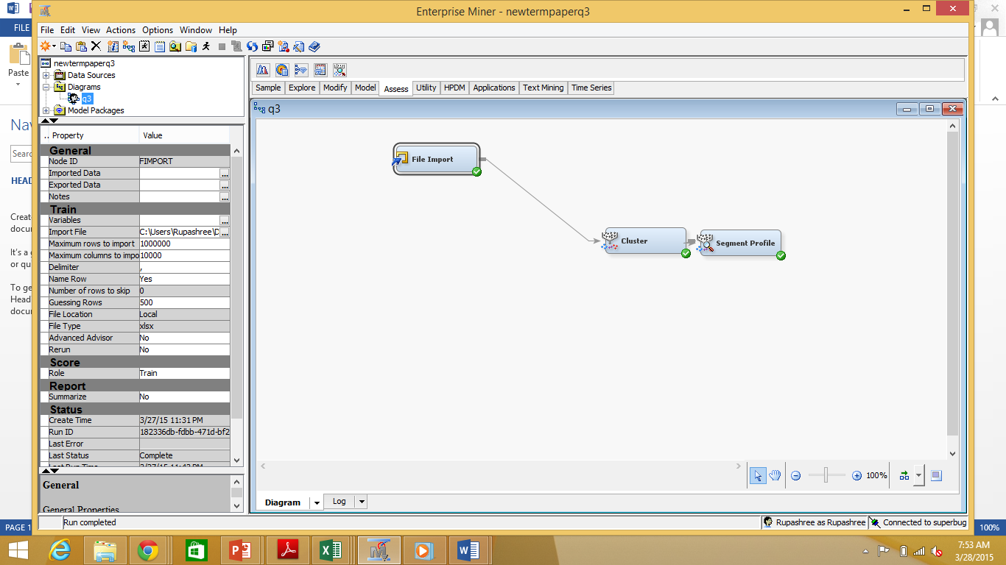

1. By right clicking on the File Import node, we clicked on Edit Variables to select the input variables and also to set the Level of each of them to its relevant values.

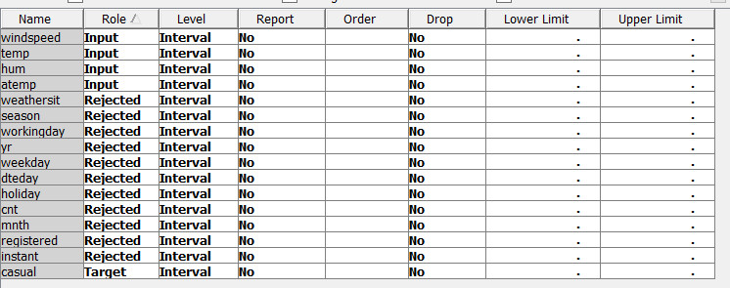

1. The File Import node is Run
2. We studied each of the variables that we intend to use as input and output for regression using the Explore tab. All the input variables except windspeed display slight normal distribution.

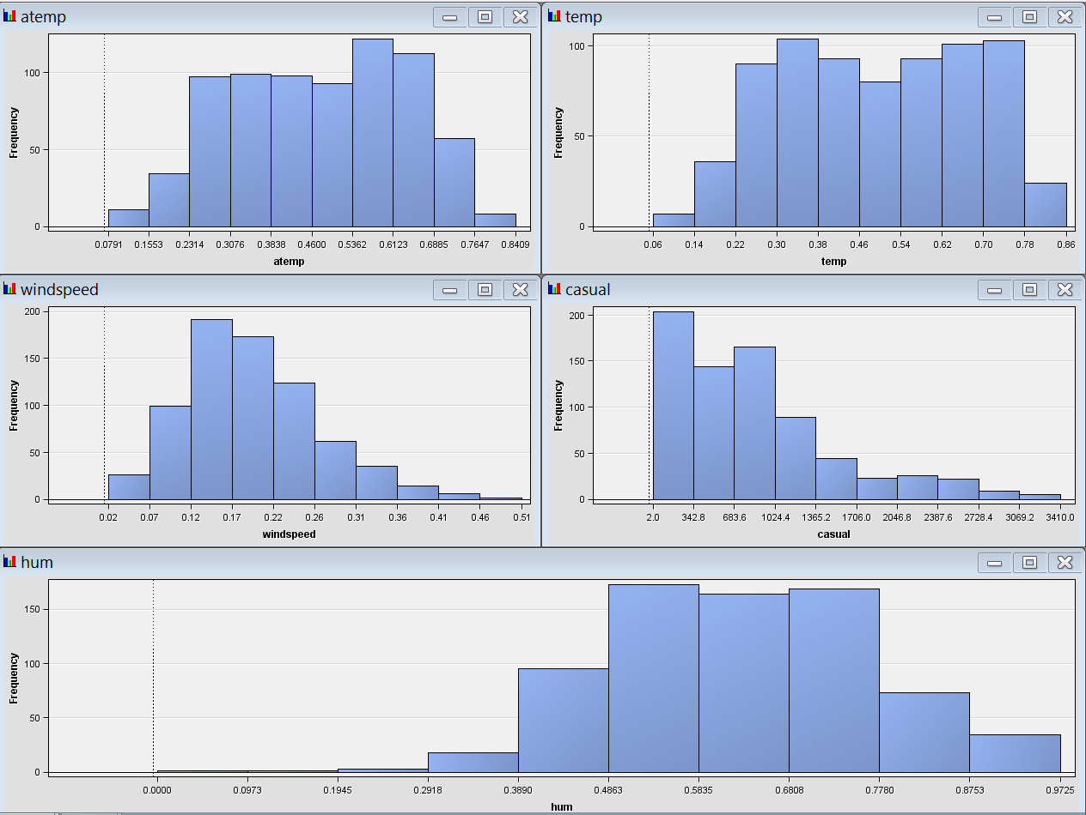

1. The sample statistics of the input and target variable are displayed below:

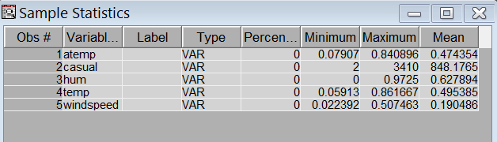

1. The Regression node is added to the diagram flow. By right clicking on the Regression node and then on Edit Variables we selected the variables that we intend to use for studying regression. The regression node was executed.

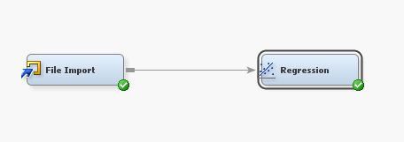

**Output:**

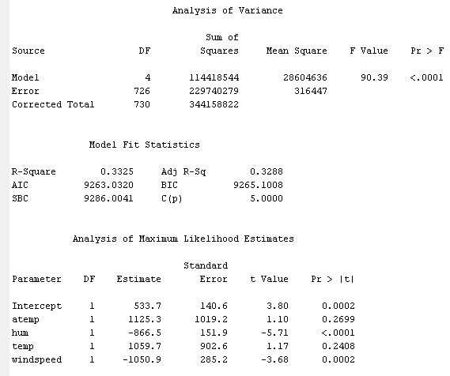

**Output Interpretation:**

The R-square value is observed to be 33.25% and the adjusted R-squared values is observed to be 32.88%. R-squared is a measure of how close the data is to the regression line. It is also known as the coefficient of determination for linear regression, or the coefficient of multiple determination for multiple regression. The adjusted R-square determines the explanatory power of regression models that contain multiple numbers of inputs/predictors.

This R-square value indicates that 33.25% variation in the dependent variable i.e. the number of casual users is determined by the variation in the independent variables namely feels like temperature, windspeed, humidity and temperature. Other 66.75% of the variation in the number of casual users is unexplained by the above mentioned independent variables. We can assume that the 66.75% of the variation in the dependent variable may be explained by other factors like season, whether the particular day is a holiday or a working day etc; information that are present in the data set and have not been used for this analysis.

It is also observed that the number of casual users is directly proportional to variables – temp, atemp and indirectly proportional to hum and windspeed. Out of the 4 inputs, atemp or feeling temperature has the highest effect on the output variable, followed by temperature, windspeed (negative effect) and then hum (negative effect). We can conclude that for every 1 degree Celsius rise in the normalized feeling temperature, the number of registered users go up by 1125. For every 1 degree Celsius rise in the normalized temperature, the number of registered users go up by 1060. Similarly for every unit increase in the normalized humidity and normalized windspeed, the number of registered users go down by 867 and 1051 respectively.

1. **Question - Do the temperature factors have an impact on the renting of bikes by registered users?**

* Dataset used – Day
* Input Variables – temp, atemp, hum, windspeed
* Output Variable – registered
* What we intend to do – By observing the R sq we intend to study the extent to which the weather factors play a role in the renting behavior of registered users

The steps followed are as below:-

1. The ‘day’ excel file is imported to SAS EM using the File Import node.



1. By right clicking on the File Import node, we clicked on Edit Variables to select the input variables and also to set the Level of each of them to its relevant values.

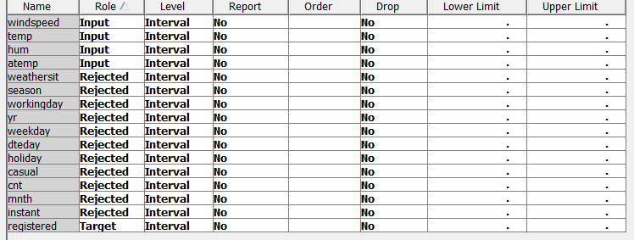

1. The File Import node is Run
2. We studied each of the variables that we intend to use as input and output for regression using the Explore tab. All the input variables except wind speed display slight normal distribution.

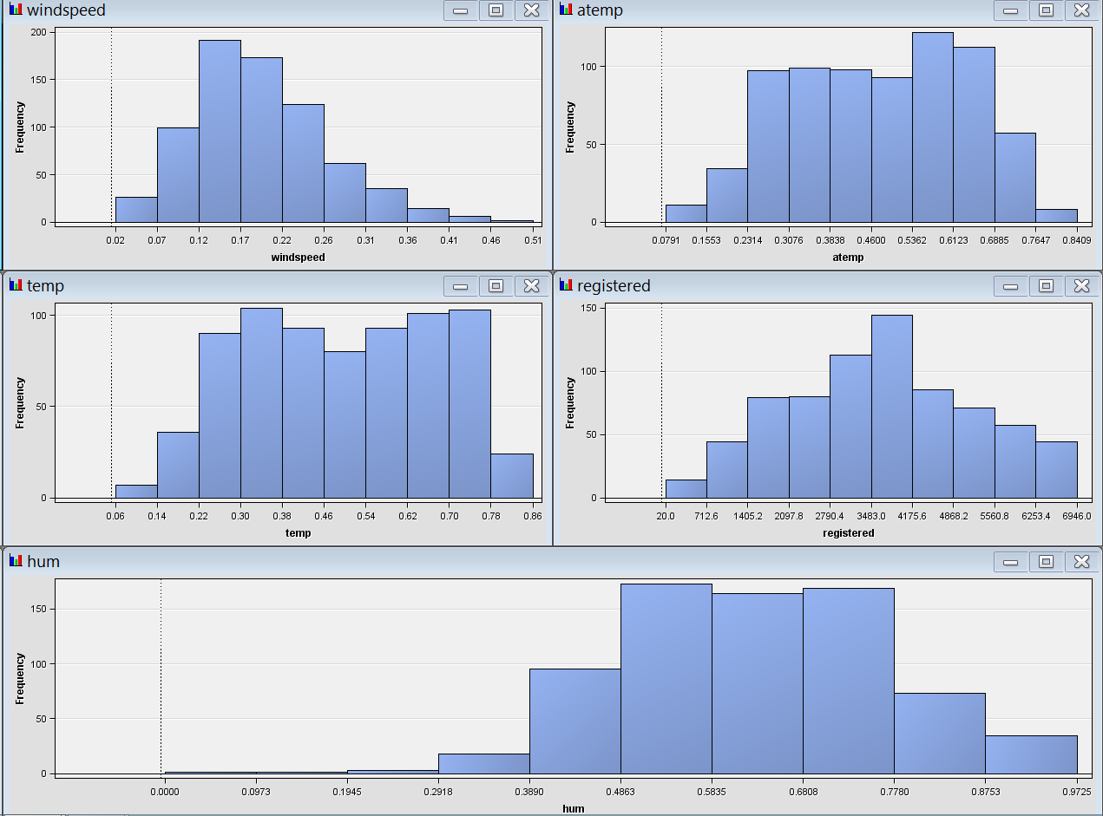

1. The sample statistics of the input and target variables are given below

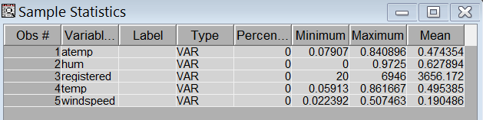

1. The Regression node is added to the diagram flow. By right clicking on the Regression node and then on Edit Variables we selected the variables that we intend to use for studying regression. The regression node was executed.



**Output:**

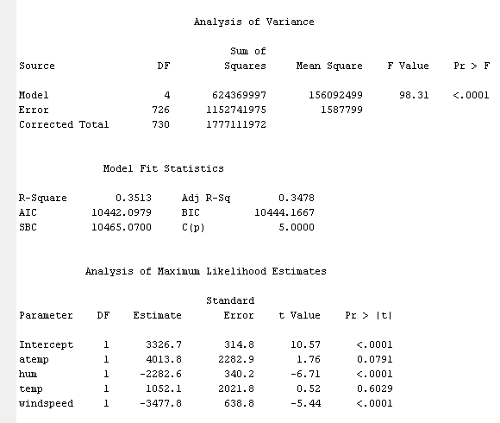

**Output Interpretation:**

The R-square value is observed to be 35.13% and the adjusted R-squared values is observed at 34.78%.

The R-square value indicates that 35.13% variation in the dependent variable i.e. the number of registered users is determined by the variation in the independent variables namely feels like temperature, wind-speed, humidity and temperature. Other 64.87% of the variation in the number of registered users is unexplained by the above independent variables and may be explained by other factors like season, whether the particular day is a holiday or a working day etc; information that are present in the data set and have not been used for this analysis.

It is also observed that the number of registered users is directly proportional to variables – temp, atemp and indirectly proportional to hum and windspeed. Out of the 4 inputs, atemp or feeling temperature has the highest effect on the output variable, followed by windspeed (negative effect), hum (negative effect) and then temperature. We can conclude that for every 1 degree Celsius rise in the normalized feeling temperature, the number of registered users go up by 4014. For every 1 degree Celsius rise in the normalized temperature, the number of registered users go up by 1052. Similarly for every unit increase in the normalized humidity and normalized windspeed, the number of registered users go down by 2283 and 3478 respectively.

## **Clustering**

Cluster analysis is an unsupervised method of grouping sets of objects or parameters such that similar parameters are grouped together in the same cluster.

After concluding from the regression analysis that the renting behavior of users are explained by weather conditions to a substantial extent, we have now clustered the data using all the weather parameters and interpreted the clusters with respect to the Profit level (which is not an input for clustering). This is to find out which weather combinations generate more business and are hence more profitable for the Bike Sharing company/system.

1. **Question - Is there more rental activity in certain combinations of weather conditions than others?**

* Dataset used- hour (as this dataset gives a more detailed weather information of each day than the day dataset)
* Input Variables – temp, atemp, hum, windspeed

The steps followed are as below:-

1. Preprocessing the dataset

As part of preprocessing the dataset we have added two attributes in the ‘hour’ dataset–

1. Revenue – We have considered the hourly rent for casual users and registered users as $5 and $3 respectively. In the revenue field, we have multiplied the rate with the number of bikes rented in the corresponding category (casual/registered) and added them.
2. Profitability level – We have considered the top 75 percentile revenue as “Very good business”, next 20 percentile as “Good business”, the next 20 percentile as “Fair business” and the bottom 35 percentile as “Loss”. We have attributed “1” to “Very good business”, “2” to “Good business”, “3” to “Fair business” and “4” to “Loss”. We thus get an ordinal data set for this attribute.

The values used in the Revenue and Profitability level columns – the hourly rates of rent and the cutoffs for profitability are based on our estimates and can be changed as per the company’s guidelines.

We have renamed the ‘hour’ dataset as “hour_preprocessed’ after adding the above mentioned attributes in it.

1. The ‘hour_preprocessed’ excel file is imported to SAS EM using the File Import node.



1. By right clicking on the File Import node, we clicked on Edit Variables to set the Role and Level of each of the variables to its relevant values.

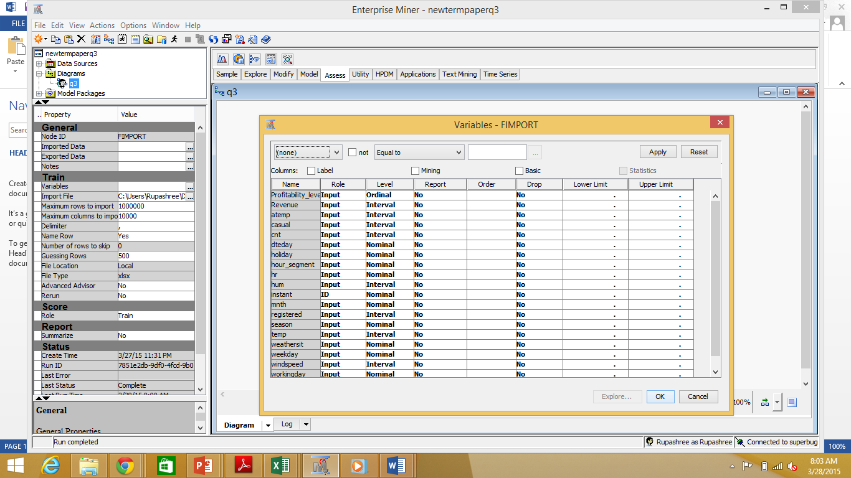

1. The File Import node is Run.
2. We studied each of the variables that we intend to use as input for clustering using the Explore tab.

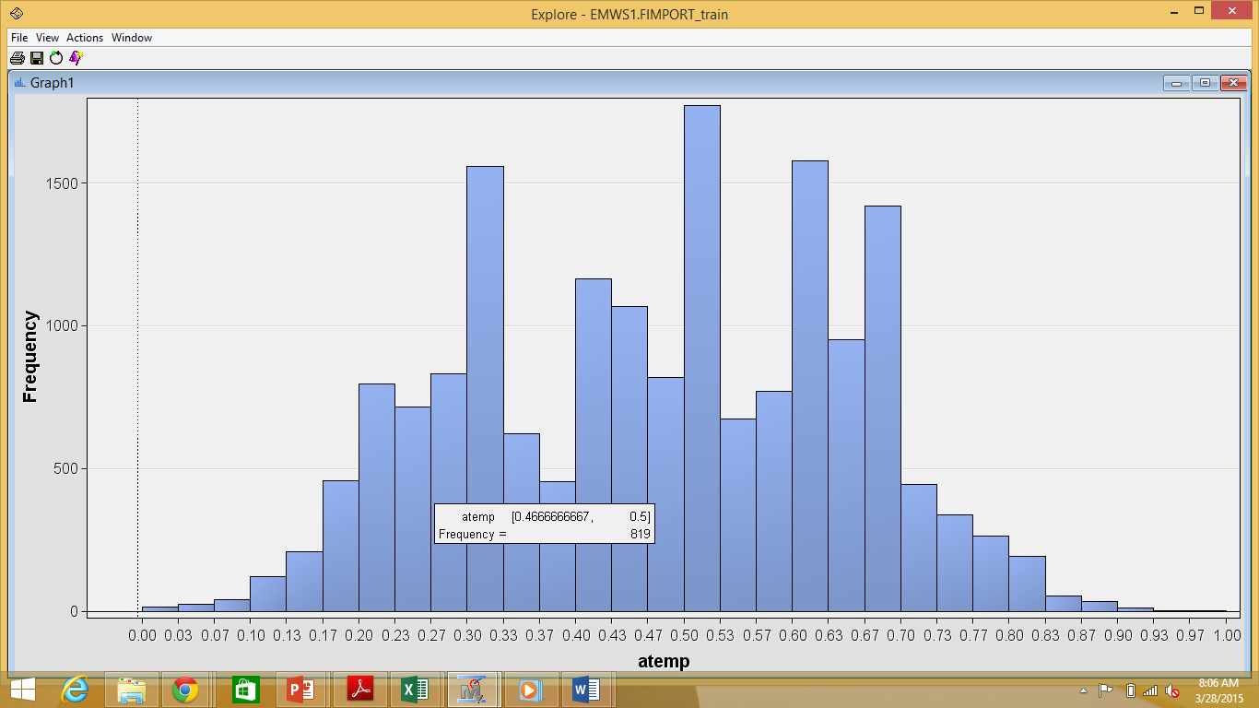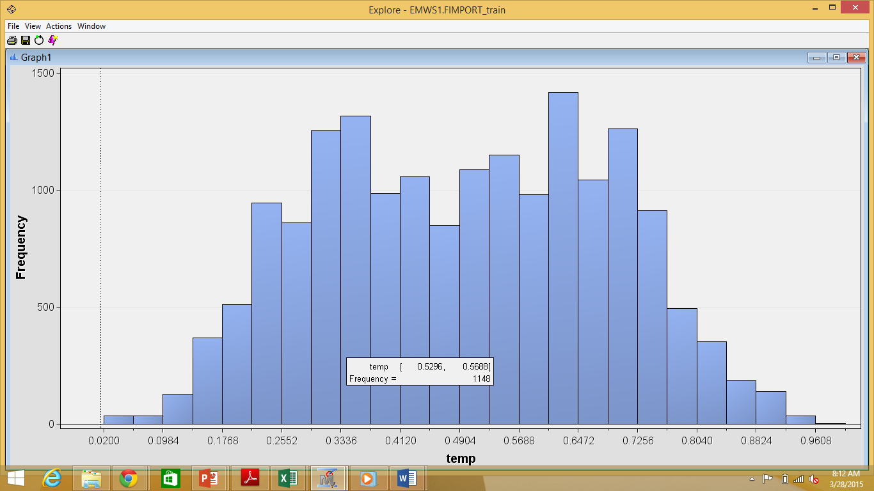

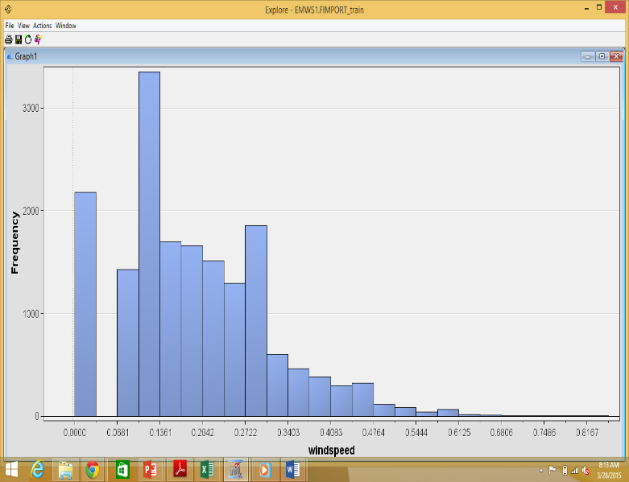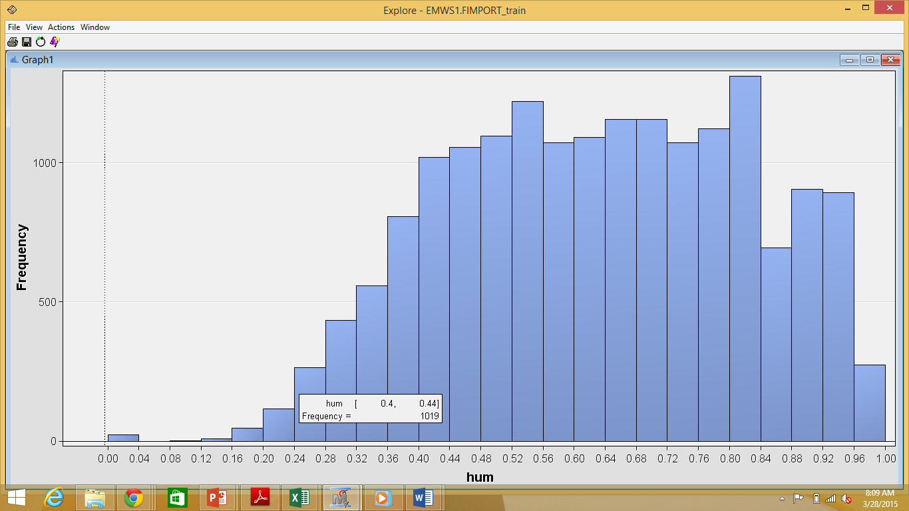

After the examination of the input variables, we found that there are no missing values in it. Also as the temp and atemp variable represents the normalized temperature and feeling temperature in Celsius respectively, they can have records having 0 value. The hum variable represents the Normalized humidity and windspeed represents Normalized wind speed. Thus these variables can also have records having 0 values. Thus there is no need to do any missing value handling before using the Cluster Node.

1. The Cluster node is added to the diagram flow. By right clicking on the Cluster node and then on Edit Variables we selected the variables that we intend to use for clustering.

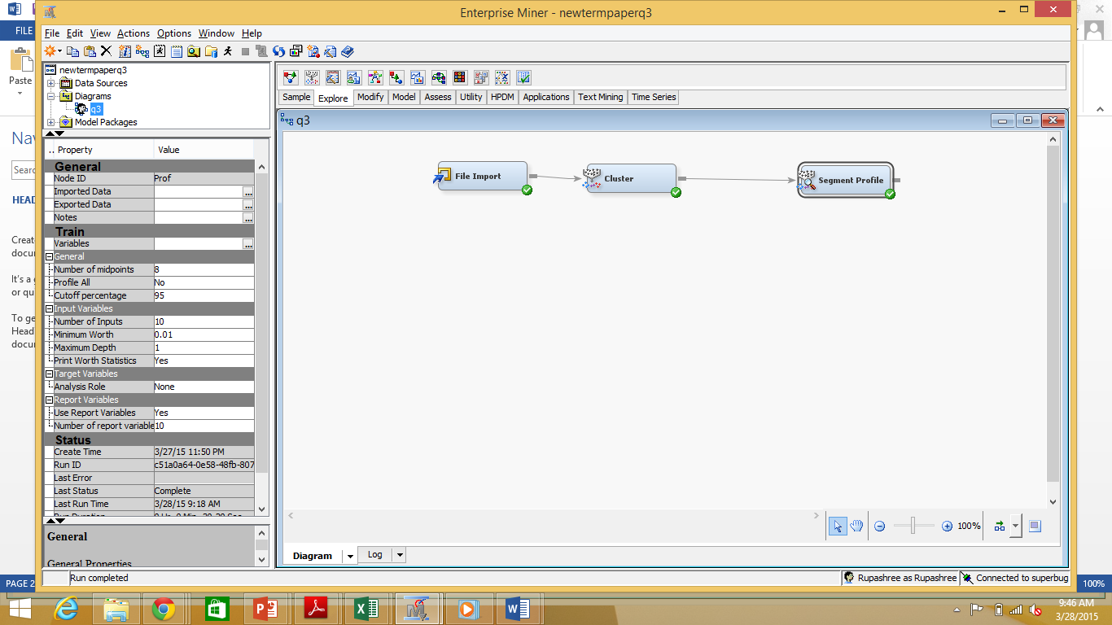

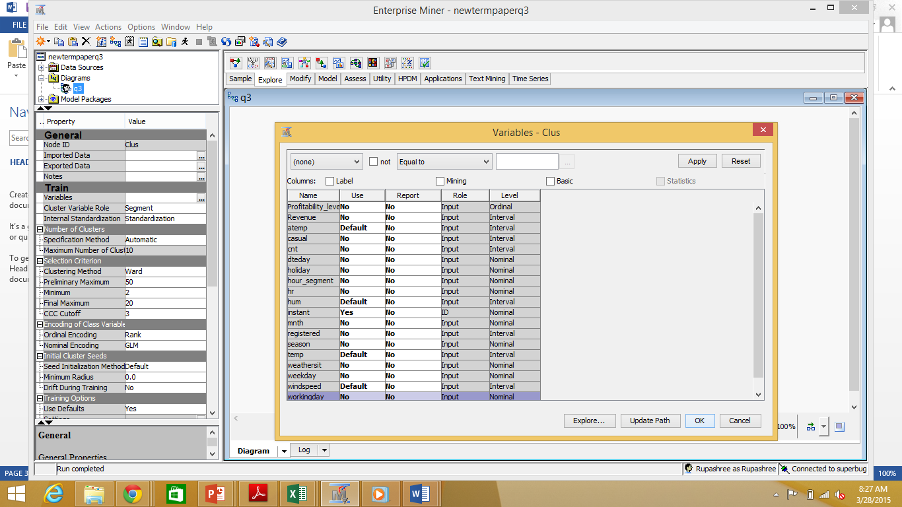

1. The Internal Standardization Train property was set to Standardization and the Cluster node was run.

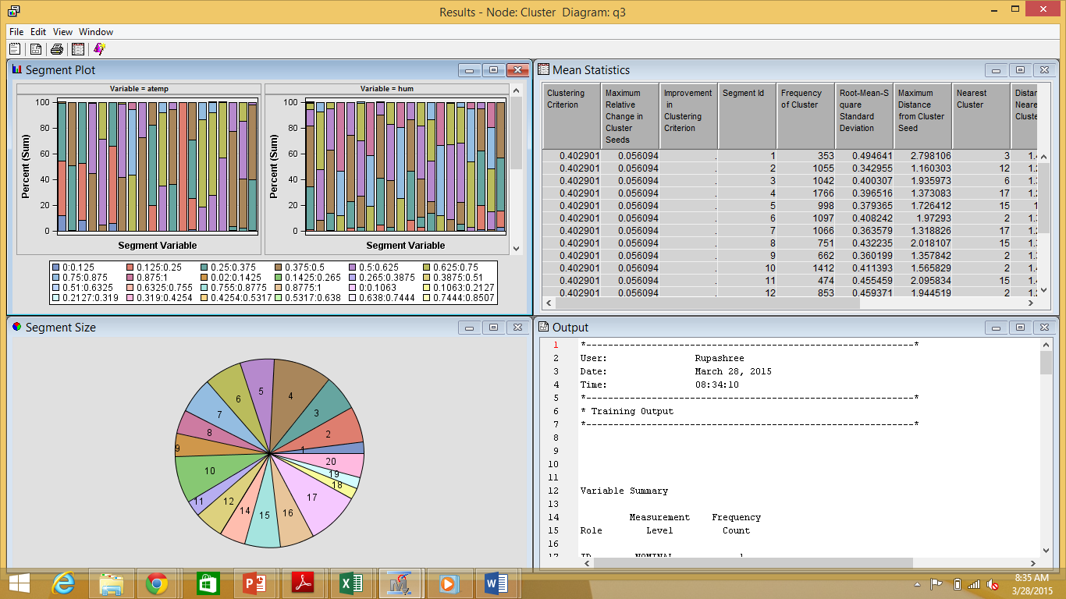

A total number of 20 clusters were formed. Considering that such a high number of clusters would pose difficulty in drawing any inferences, we decided to set the *Maximum number of Clusters* property to a user specified value. After some trial and error, we decided on creating 6 clusters after considering factors like the balance of ‘Frequency of Clusters’ etc.

**Output:**

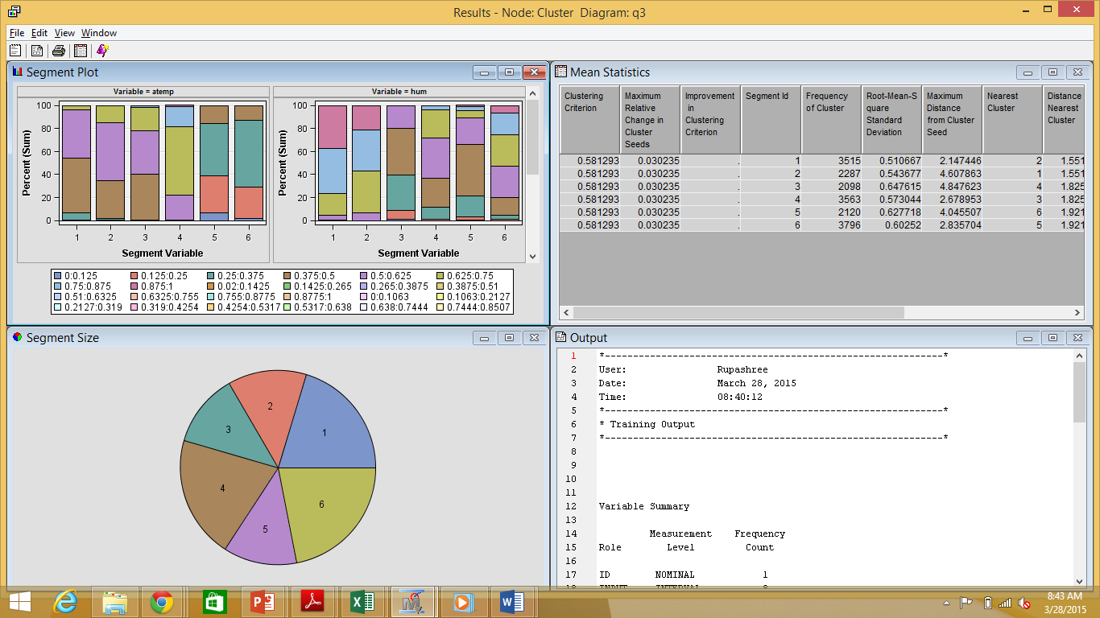

**Output Interpretation:**

For interpreting the clusters with respect to the input variables, we have used the Segment Profile node and selected the input variables from Edit Variables.

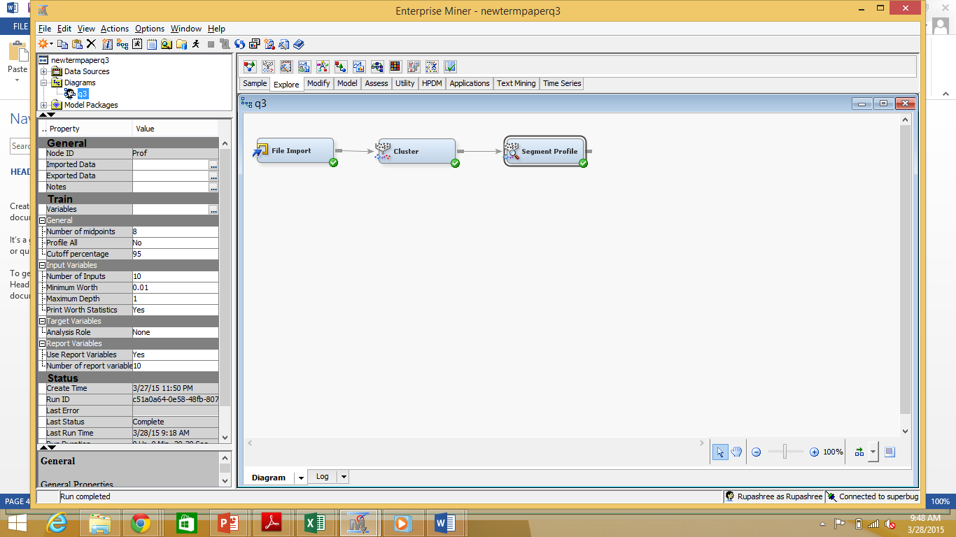

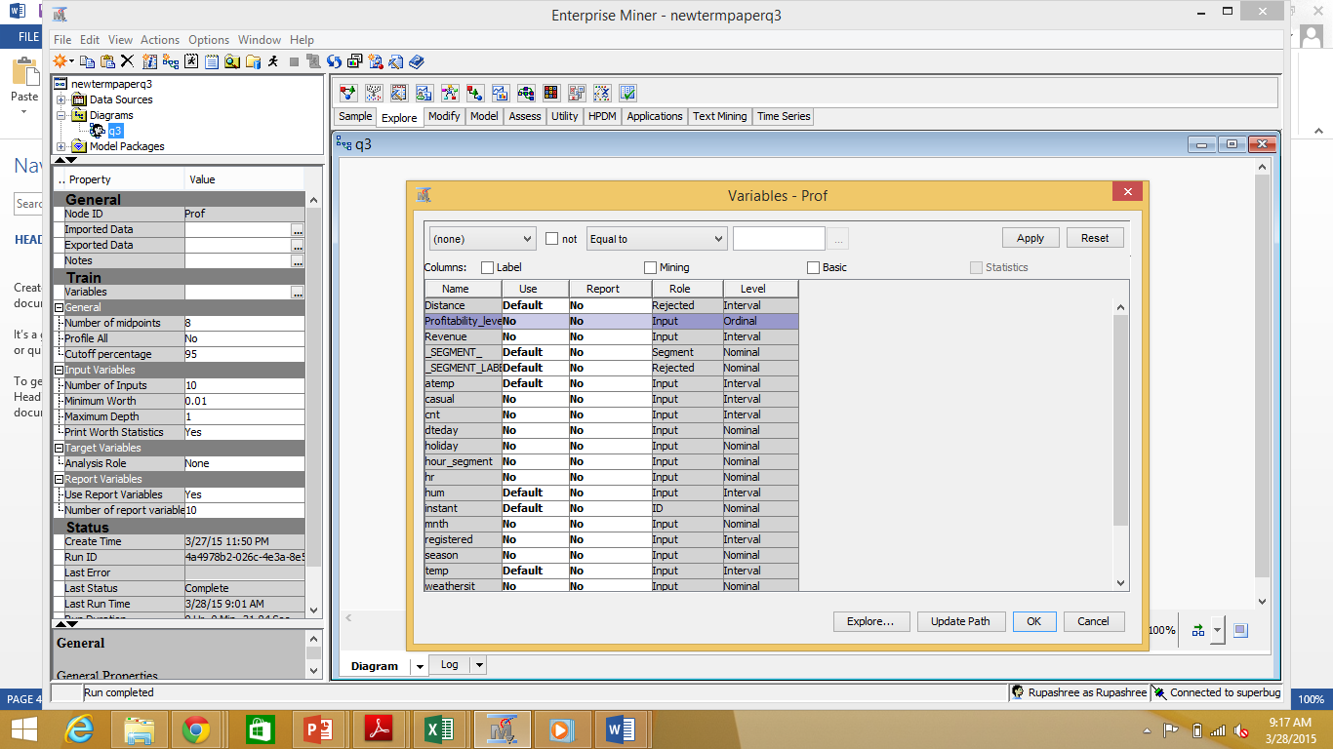

The Node Segment Profile graphs show the distribution of the input variables in each of the clusters:-

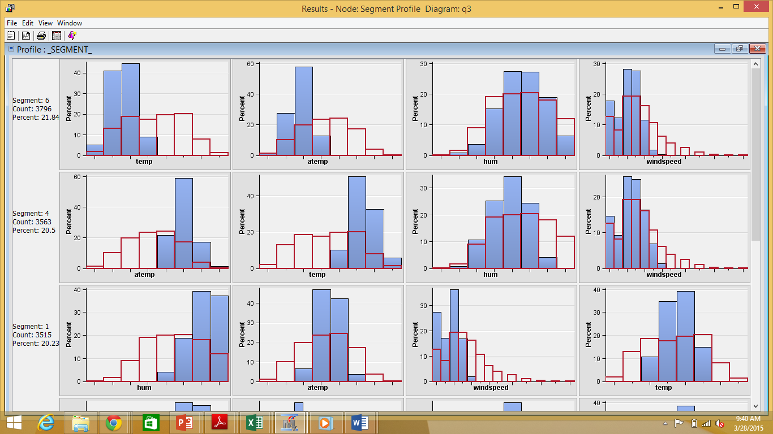

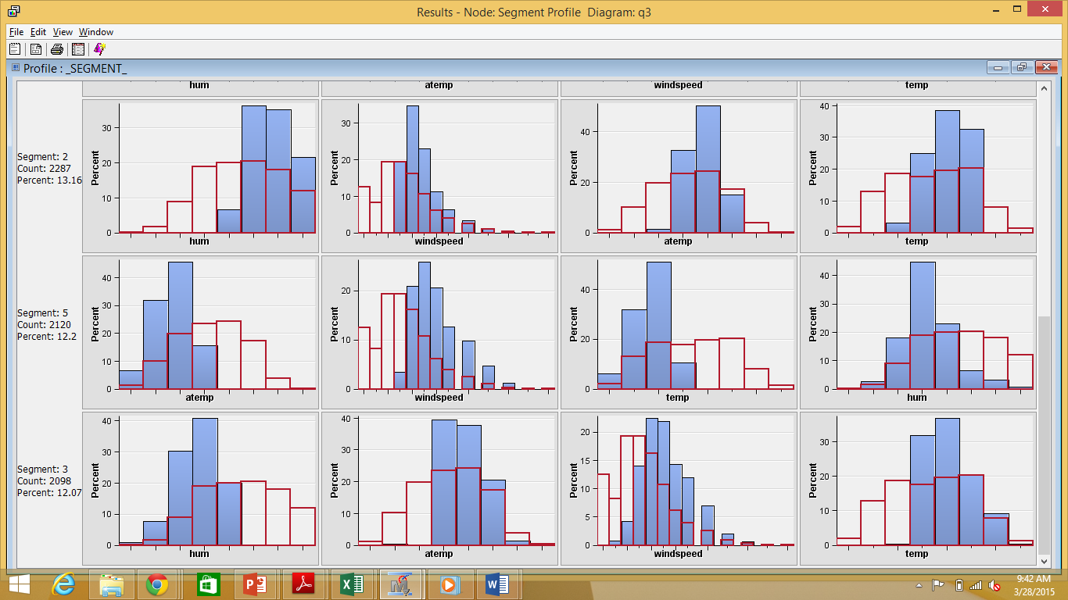

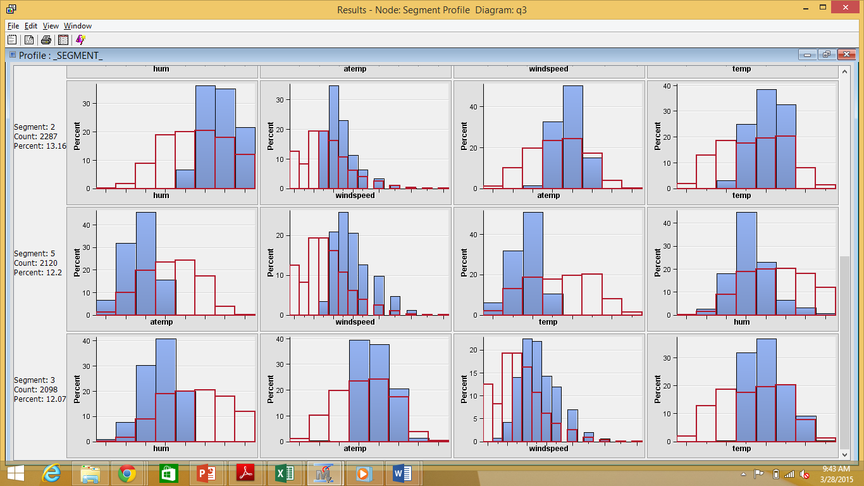



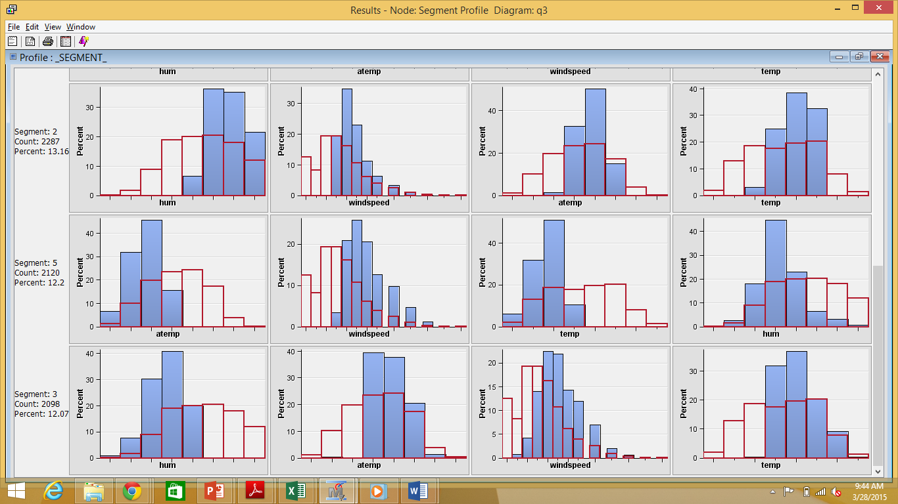



We have thus proposed names for each of the clusters based on their dominant weather conditions:-

|  |  |  |  |  |
| --- | --- | --- | --- | --- |
| **Cluster** | **Temperature (actual & feels like)** | **Humidity** | **Wind Speed** | **Proposed Name** |
| 1 | Average | High | Low | Seattle Gloom |
| 2 | Slightly high | High | High | Tropical Sun |
| 3 | High | Low | High | Chicago Summers |
| 4 | High | Low | Low | Wild West Texas |
| 5 | Low | Low | High | Boston Freeze |
| 6 | Low | High | Low | The Big Ben |

By clicking on the *ellipses* of the *Exported data* of the *Cluster* node, we observed the following trend of Profitability Level for each of the 6 clusters.

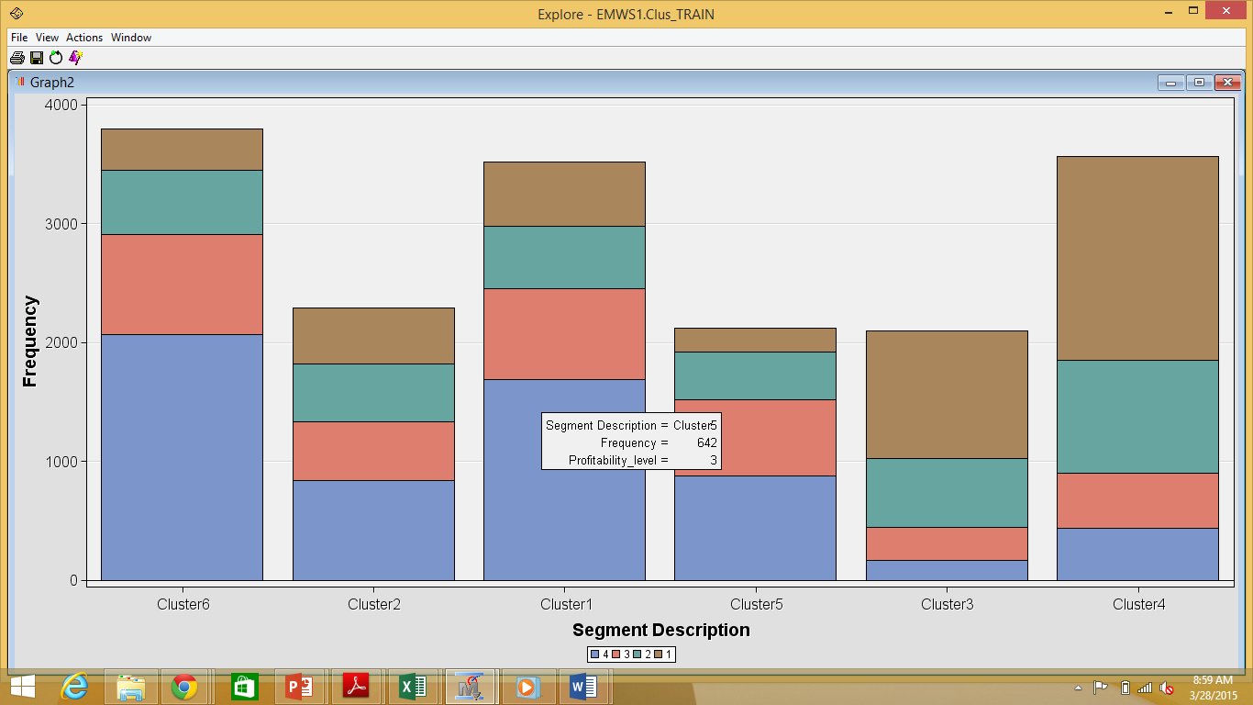

We thus observe the following:

1. Clusters 3 and 4 have a higher than average profitability level
2. Clusters 2 and 5 have average profitability
3. Clusters 1 and 6 have a lower than average profitability level

## **Predictive Modeling: Optimal Tree, Interactive Tree & Logistic Regression**

Predictive modeling is the method of creating statistical models that extract useful information from existing data to determine patterns and predict future outcomes.

We concluded in the previous sections that the renting behavior of users are explained by weather conditions to a substantial extent and that certain weather combinations are more favorable to users renting bikes and are thus more profitable for the Bike Sharing company/system. In this section, we have used different predictive models to determine whether a given day will be profitable for the Bike Sharing company/system given the environmental parameters and other information about the particular day.

1. **Question** – **Whether a given day would be profitable for the Bike Share company/system based on information like environmental parameters, whether it is a working day or a holiday, the month etc?**

* Dataset used - day
* Input Variables – temp, atemp, hum, windspeed, weathersit, season, mnth, weekday, workingday
* Target Variable – Profitability_level

The steps followed are as below:-

1. Preprocessing the dataset on the excel sheet

We have added two attributes in the ‘day’ dataset–

1. Revenue – We have considered the average bike rent per day for casual users and registered users as $12 and $10 respectively. In the revenue field, we have multiplied the rate with the number of bikes rented in the corresponding category (casual/registered) and added them.
2. Profitability level – We have considered the revenue above the median as “Profitable”, and below median as “Not Profitable”. We have attributed “1” to “Profitable” and “0” to “Not Profitable”. We thus get a binary data set for this attribute.

The values used in the Revenue and Profitability level columns – the average daily rates of rent and the cutoffs for profitability are based on our estimates and can be changed as per the company’s guidelines.

We have renamed the ‘day’ dataset as “day_preprocessed’ after adding the above mentioned attributes in it.

1. The ‘day_preprocessed’ excel file is imported to SAS EM using the File Import node.

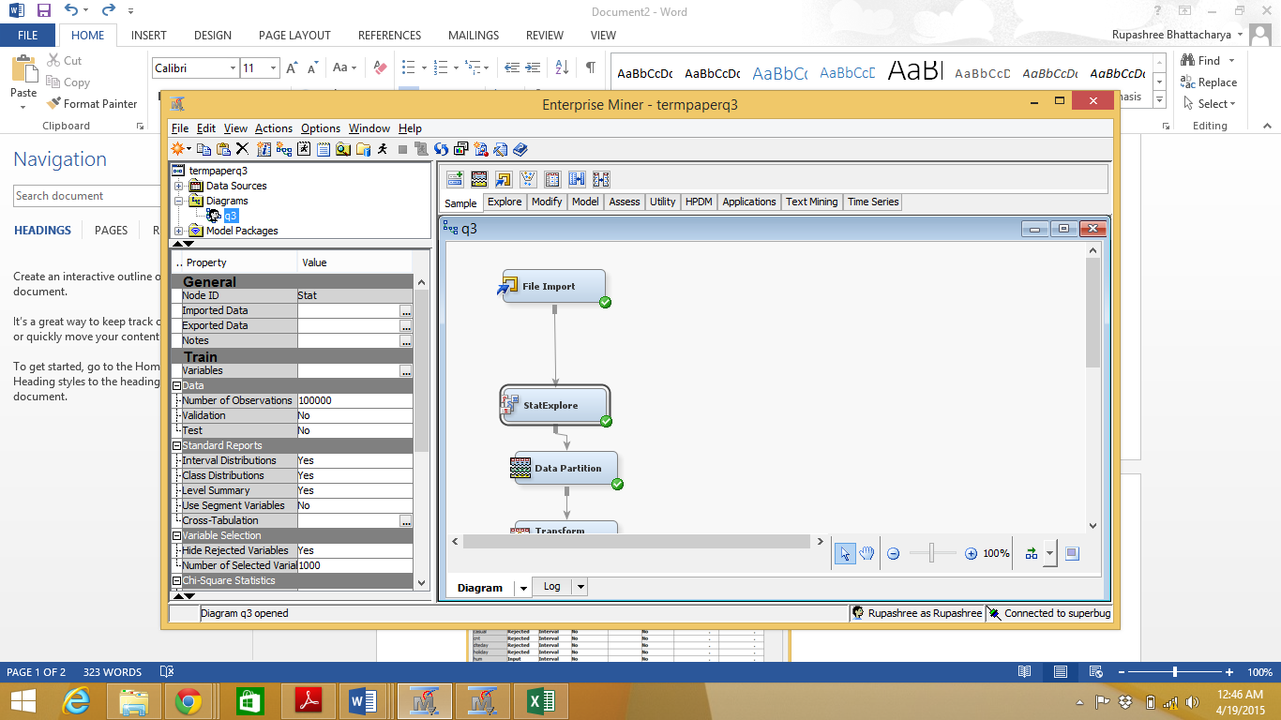

1. By right clicking on the File Import node, we clicked on Edit Variables to set the Role and Level of each of the variables to its relevant values.



1. The File Import node is Run
2. We then added a *StatExplore* node to the imported datasource to study the statistical summary of the input data.

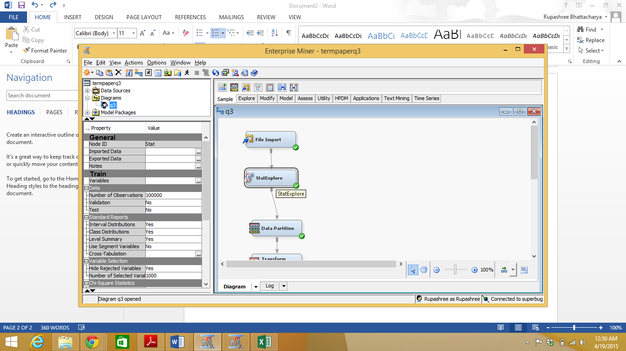

The StatExplore node formulates Chi-Square statistics which checks whether distributions of categorical variables are different from one another. As we have interval variables in addition to categorical variables in our data set, we needed to bin the interval variables before using this node, for chi-square statistics to be calculated. Hence we set the *Interval Variables* property under *Chi-Square Statistics*for the StatExplore node to ‘Yes’.

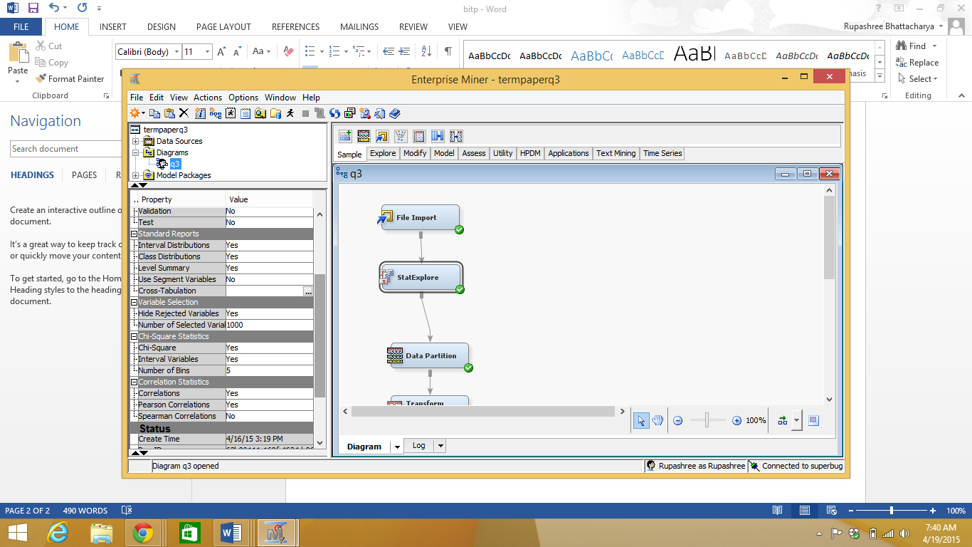

1. We executed the StatExplore node.

The Result window displays the following:-

1. The *Variable Worth* plot orders the variables by their worth in predicting the target variable based on the Gini split worth statistic.
2. The SAS output window provides distribution and summary statistics for the class and interval inputs.
3. The *Chi-square* plot orders the top 20 variables based on their chi-square statistics.

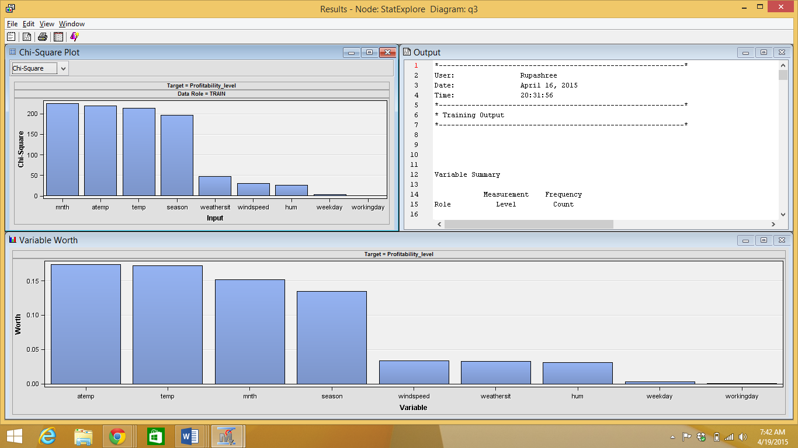

By observing the *Class Variable Summary Statistics* and the *Interval Variable Summary Statistics* sections of the Output in more detail, we saw that none of the Class as well Interval variables have missing values.

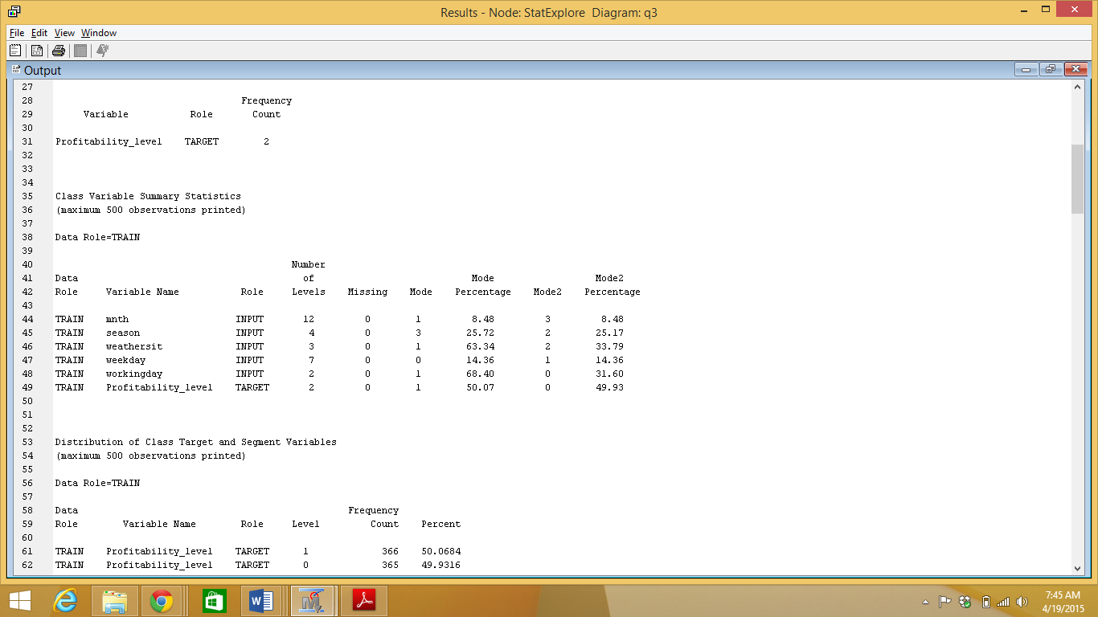

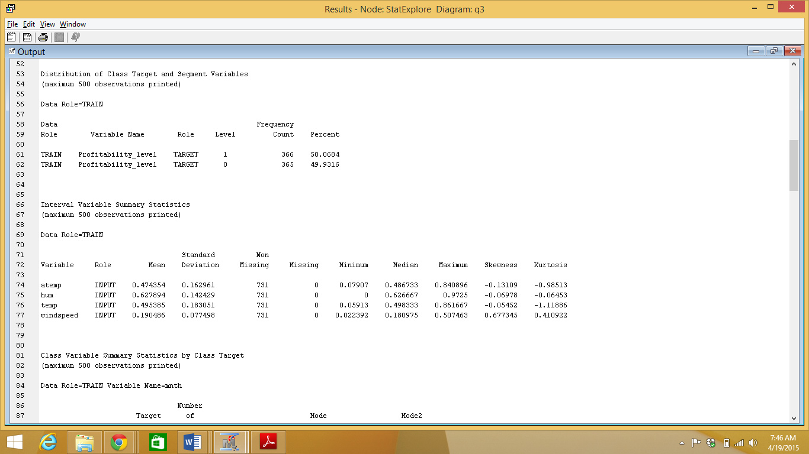

As it is difficult to conclude whether a given variance is large or not, we considered *Coefficient of Variation* to measure variance. We thus calculated the Coefficient of Variation of all Interval variables by dividing their Standard Deviation with their Mean; the values of which we got from the *Interval Variable Summary Statistics sections* of the Output of *StatExplore*. We considered a threshold of 1, i.e. variables having Coefficient of Variation 1 and above have high variance and variables having Coefficient of Variation lesser than 1 have low variance. We observed that all variables have their coefficient of variation value as less than 1 and hence are considered having low variance.

1. The Data Partition node was added by setting the *training* and *validation* property in *Data Set Allocation* to 55.0 and 45.0 respectively. The node was executed.

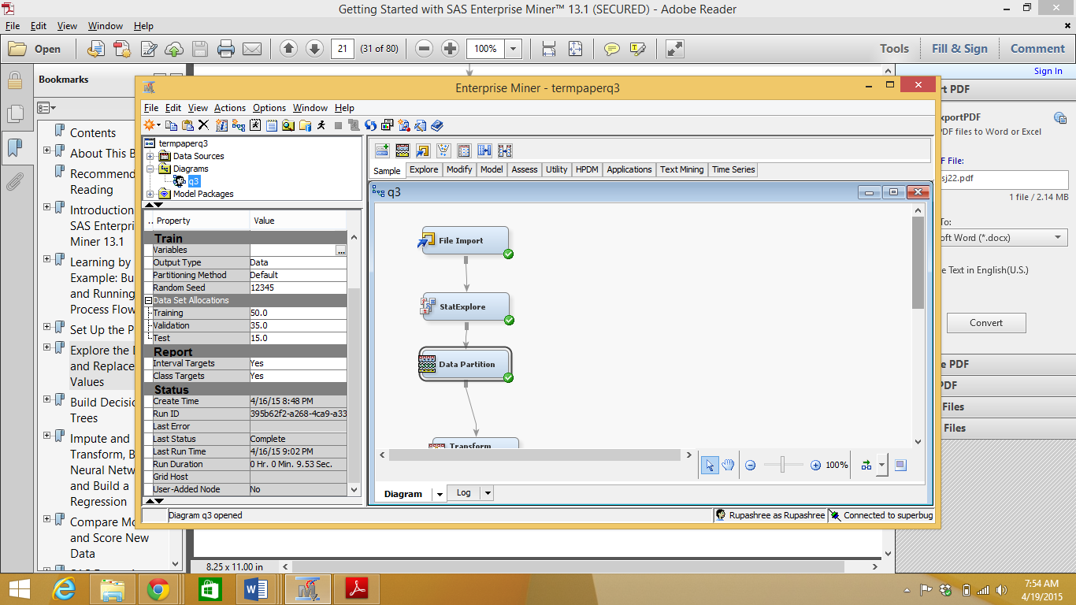

1. We then added a Transform Variables node to the process flow to perform required transformations on the data set to ensure a better model fit.

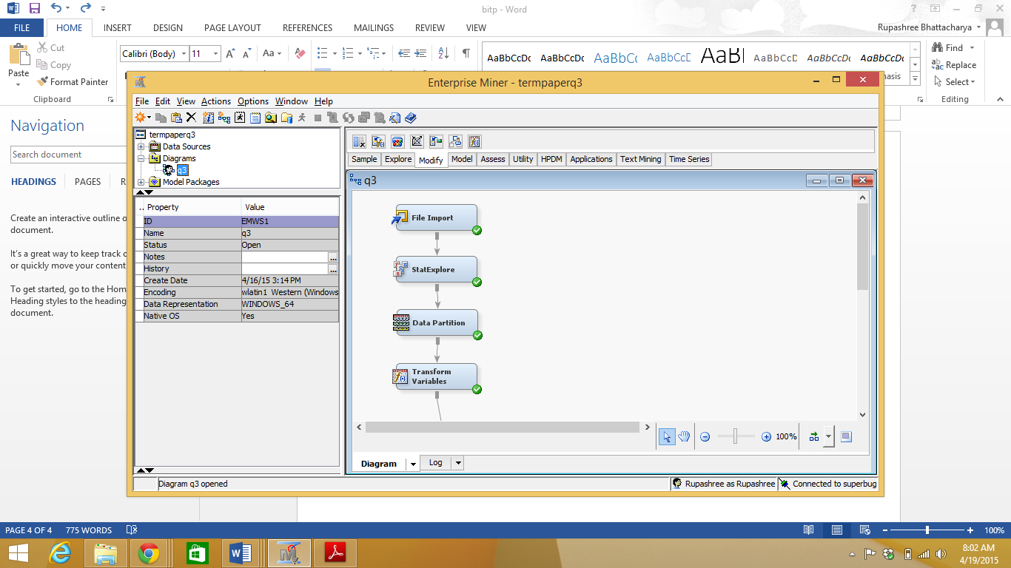

1. We clicked on the *Formulas ellipses* in the Train properties of the node to observe the histogram of all the input interval variables.

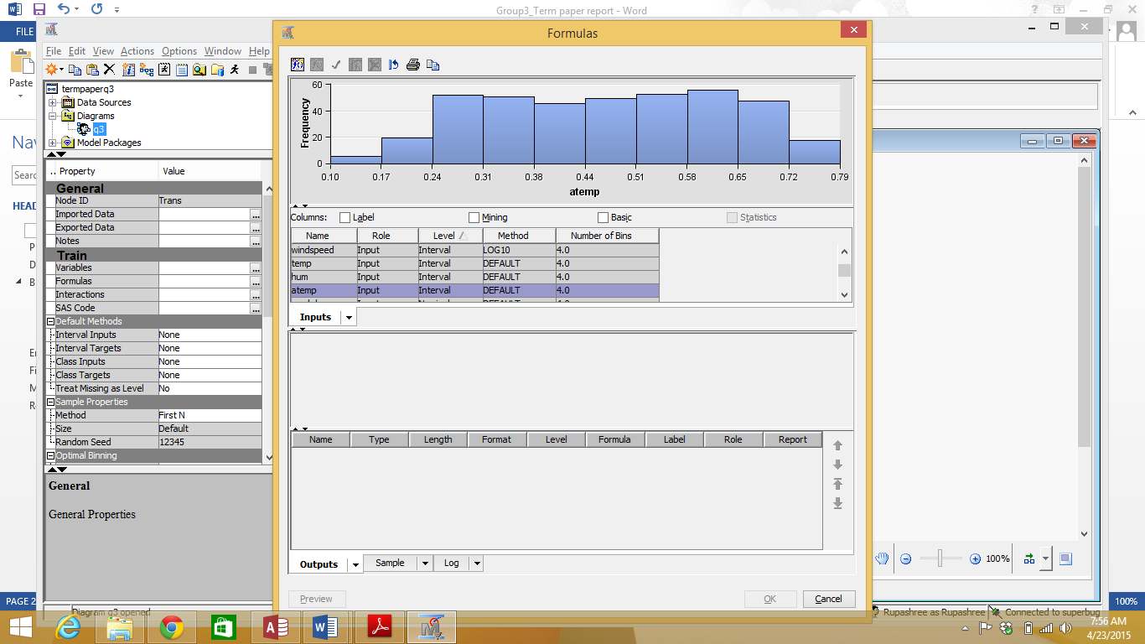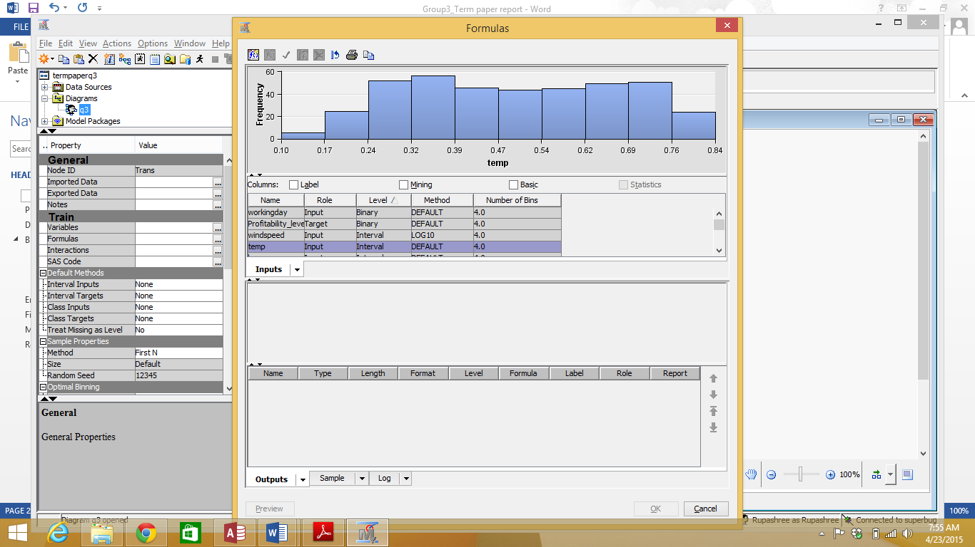

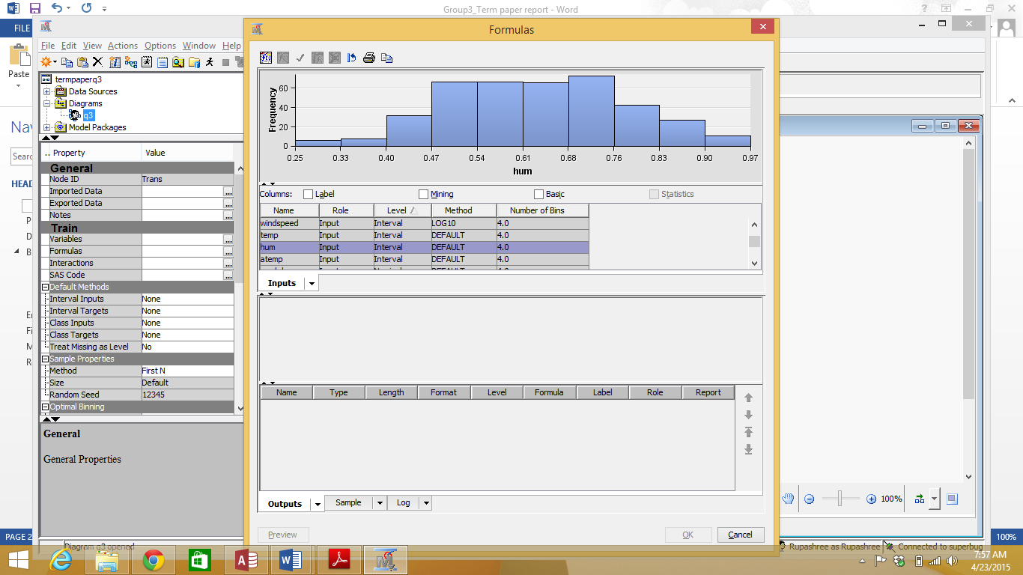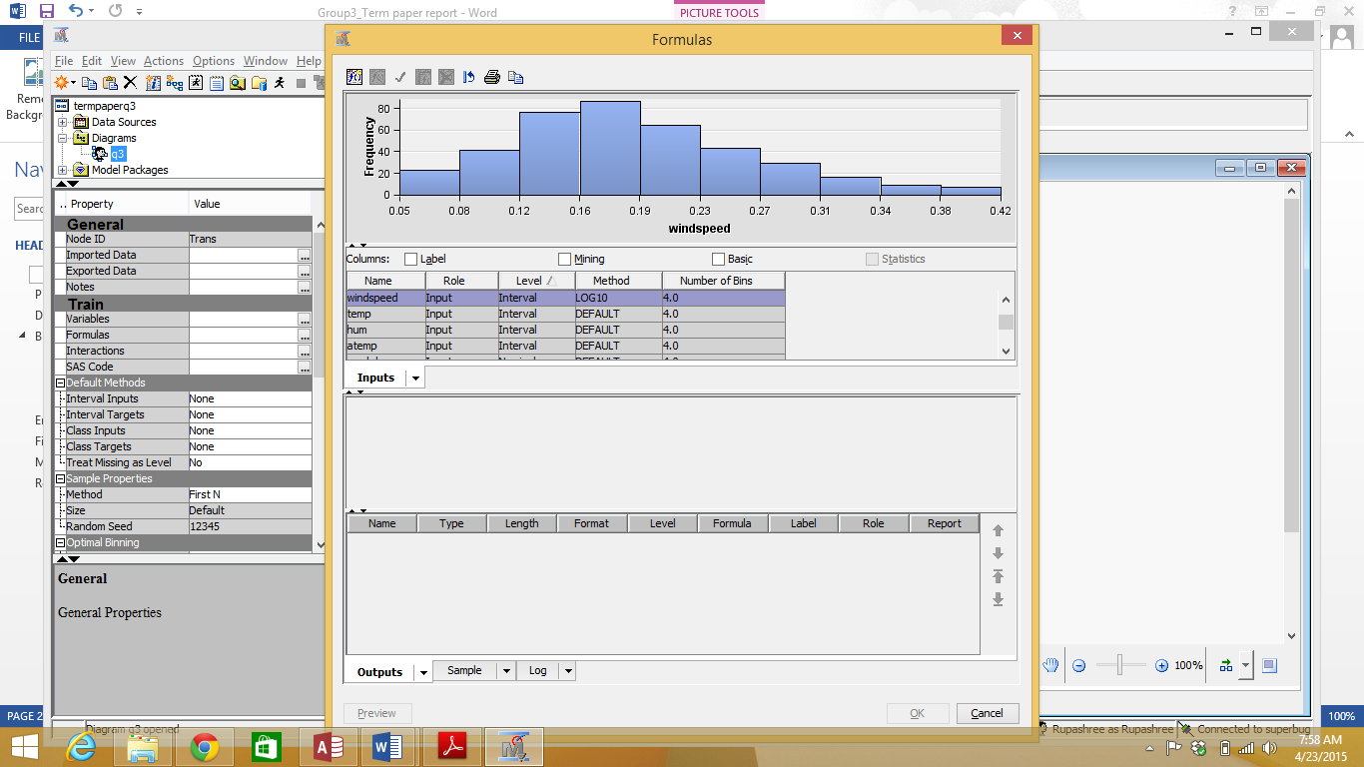

We observed that the variable windspeed has a slight positive skewed distribution.

Hence, we selected *Log10* as the *transformation Method* in the *Variables – Trans* window for the windspeed variable. Log transformations are used to control skewness.

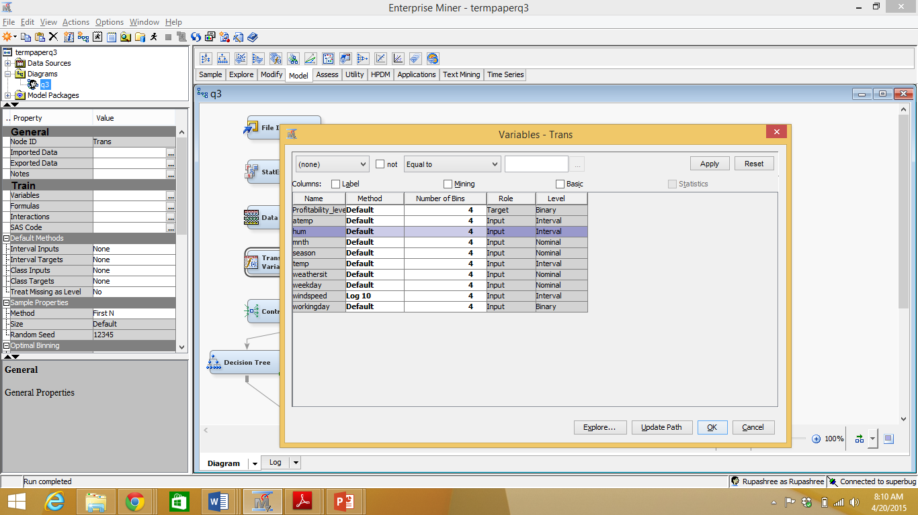

1. We then executed the node.
2. We added the *Control Point* node to the flow. It is used to simplify a process flow diagram by reducing the number of connections between multiple interconnected nodes.
3. We added a *Decision Tree* node in the process flow.

Decision trees are created by algorithms that identify various ways of partitioning the dataset into smaller and purer branches/subsets until a termination criteria is reached.

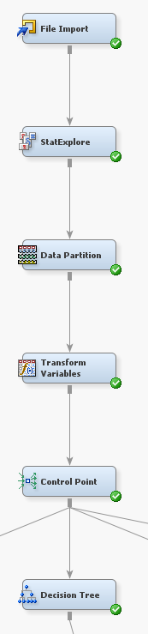

1. In the Decision Tree node, in the Properties Panel, under Train properties, we made the below settings:
   1. *Maximum Depth splitting* rule property was set to 10.
   2. *Leaf Size* node property was set to 8.
   3. *Number of Surrogate Rules* node property was set to 4.

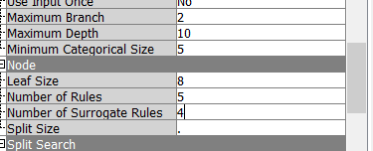

* 1. *Assessment Measure*subtree property was set to Average Square error. This enables SAS Enterprise Miner to select the best tree with the least average square error, based on the validation data.



1. After making these changes we executed the decision tree node.

**Output**

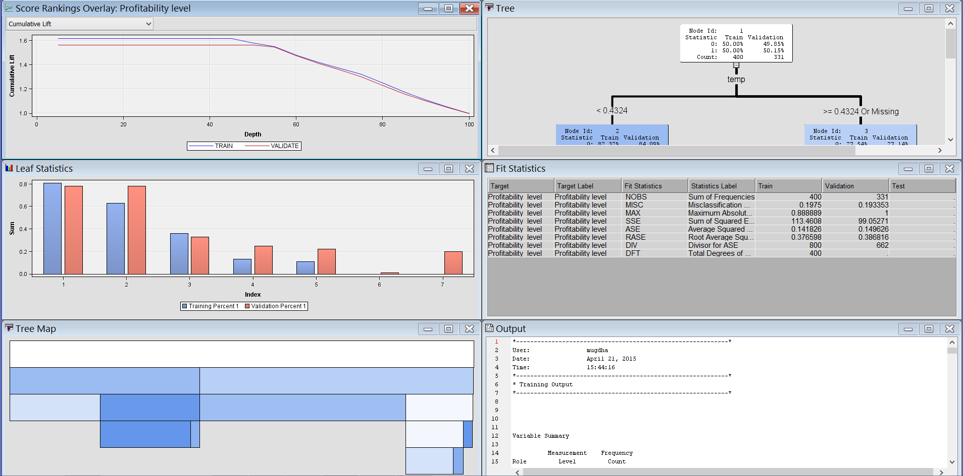

**Output Interpretation:**

The decision tree is a classification tool which we have employed to predict the profitability level. We are trying to find whether given certain input parameters, a given day will be profitable or not. We have divided the dataset into training and validation data. Training data is used for building the model and the validation dataset is used to select the best model and fine tune the parameters used. The target we have kept for predictive modelling using Decision tree is Profitability_level.

The assessment measure was decided as average square error. The average square error is very important in the evaluation of accuracy and precision of a predictive model. It is the square root of the mean of the square of all the difference between the actual and the predicted values. SAS EM tries to create an optimal tree based on the lowest average square error as a criteria.

The optimal tree created is shown below:

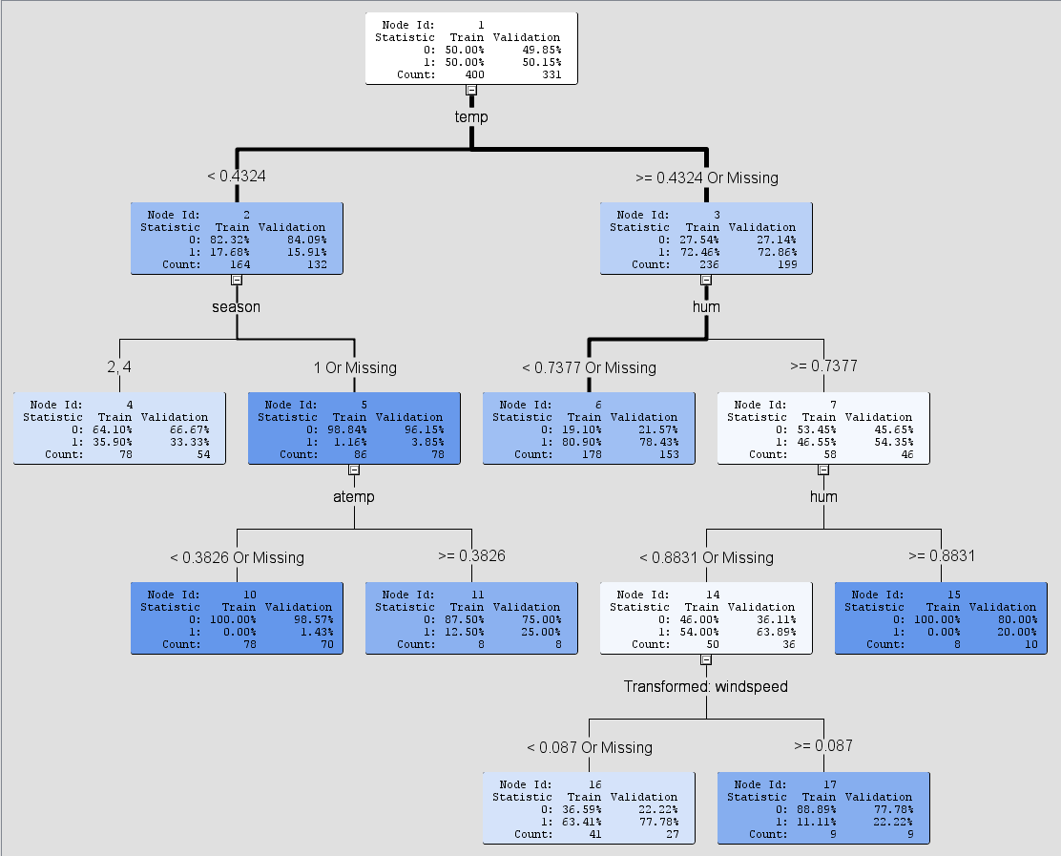

The optimal tree that is formed, initially splits on the attribute temp with highest logworth. The leaves thus formed have a fairly higher than average concentration of 0’s in the training data set for the condition <0.4322 and a fairly higher than average number of 1’s in the training set for >=0.4322.

After that, the second node is split on the attribute season. This split creates two leaves using the condition 2, 4 and the other condition 1 or missing. The node 3 is split further with the attribute hum. In the leaf split on the condition of month 0.7377 or missing, we find that there is a further split on the attribute, hum on node 7. This creates a pure set on node 15 with condition >=0.8831

The node 5 is split further using attribute atemp with condition <0.3826 or missing and a pure set is created. The other split happens on the condition >=0.3826. Node 14 is further split on transformed attribute windspeed.

By looking at the tree we can observe the following rules for the tree:

*Node = 4*

*if temp < 0.43237 AND season IS ONE OF: 2, 4, then, Tree Node Identifier = 4*

*Number of Observations = 78*

*Predicted: Profitability_level=1 = 0.36*

*Predicted: Profitability_level=0 = 0.64*

*Node = 6*

*if temp >= 0.43237 or MISSING AND hum < 0.73771 or MISSING, then, Tree Node Identifier = 6*

*Number of Observations = 178*

*Predicted: Profitability_level=1 = 0.81*

*Predicted: Profitability_level=0 = 0.19*

*Node = 10*

*if temp < 0.43237 AND season IS ONE OF: 1 or MISSING AND atemp < 0.3826 or MISSING, then, Tree Node Identifier = 10*

*Number of Observations = 78*

*Predicted: Profitability_level=1 = 0.00*

*Predicted: Profitability_level=0 = 1.00*

*Node = 11*

*if temp < 0.43237 AND season IS ONE OF: 1 or MISSING AND atemp >= 0.3826, then, Tree Node Identifier = 11*

*Number of Observations = 8*

*Predicted: Profitability_level=1 = 0.13*

*Predicted: Profitability_level=0 = 0.88*

*Node = 15*

*if temp >= 0.43237 or MISSING AND hum >= 0.88313, then, Tree Node Identifier = 15*

*Number of Observations = 8*

*Predicted: Profitability_level=1 = 0.00*

*Predicted: Profitability_level=0 = 1.00*

*Node = 16*

*if temp >= 0.43237 or MISSING AND hum < 0.88313 AND hum >= 0.73771 or MISSING AND Transformed: windspeed < 0.08697 or MISSING, then, Tree Node Identifier = 16*

*Number of Observations = 41*

*Predicted: Profitability_level=1 = 0.63*

*Predicted: Profitability_level=0 = 0.37*

*Node = 17*

*if temp >= 0.43237 or MISSING AND hum < 0.88313 AND hum >= 0.73771 or MISSING AND Transformed: windspeed >= 0.08697, then, Tree Node Identifier = 17*

*Number of Observations = 9*

*Predicted: Profitability_level=1 = 0.11*

*Predicted: Profitability_level=0 = 0.89*

The logworth value is indicative of the effectiveness of the decision split for a node, thus useful in determining the target variable. The leaf nodes thus formed have purer and purer subsets as we traverse down the various levels in the tree.

The subtree assessment plot for the average square error rate shows that the error displays a downward trend in both the training and validation dataset. Till the 2nd leaf the error in both the training and validation data shows a steep fall, after which the error decreases at a more gradual rate, with the error in the training data set decreasing more than that of the validation data set.

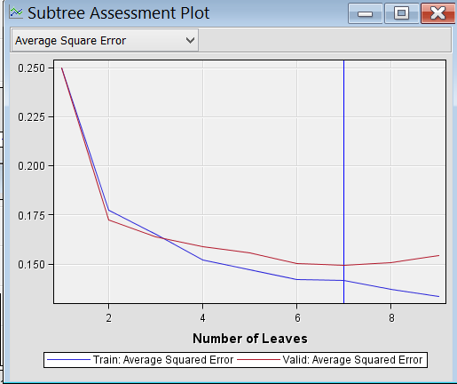

The misclassification error is observed to be 0.1975 in the training set and 0.193353 in the validation set. The average square error is 0.141826 in the training set and 0.149626 in the validation set. The Leaf statistics graph shows the predicted outcome percentages in the training and the observed outcome percentages in the validation set for each leaf. We observed that the training data results have reflected fairly well on the validation dataset.

From the variable importance window, we can get that

* temp explains 97.66% of the variability in the target variable – profitability level, relative to the 100% variability explained by atemp
* mnth explains 93.94% of the variability in the target variable – profitability level, relative to the 100% variability explained by atemp
* season explains 91.57% of the variability in the target variable – profitability level, relative to the 100% variability explained by atemp
* Transformed windspeed explains 76.86% in the target variable – profitability level, relative to the 100% variability explained by atemp
* Hum explains 59.02% in the target variable – profitability level, relative to the 100% variability explained by atemp
* Weathersit explains 41.94% in the target variable – profitability level, relative to the 100% variability explained by atemp

We can observe that workingday and weekday variables do not explain any variability in the target variable – profitability level, relative to that explained by the atemp variable.

The cumulative lift graph in the Score ranking overlay window indicates that the records in the first 50 percentiles have a lift value of 1.6. The lift value decreases as the predicted probabilities reduces in the remaining percentiles.

1. We added another *Decision Tree* node after the *Control Point* in the process flow and renamed it as ‘*Interactive Decision Tree*’.

In this node, we created the tree interactively and at each step, by selecting from a list of candidate rules to define the split rule that seemed to be the best and thus create a maximal tree.

Using interactive training of the decision tree node, we can override the conditions defining a splitting rule or by pruning a node or subtree. We added split points and edited the splitting conditions as needed.

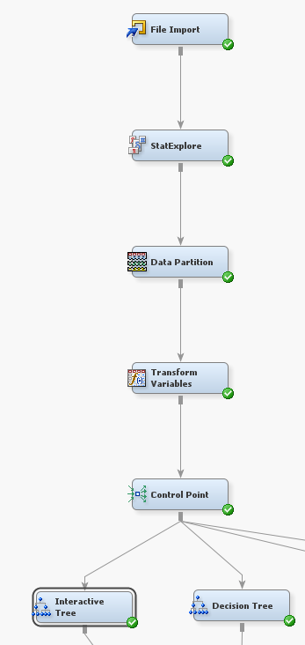

xv) We selected the *Interactive* ellipsis from the Decision tree properties panel and in the *interactive decision tree* window, split the root node into further subnodes based on the temp attribute. We edited the split rule manually to specify the split point for this rule. We entered *0.45* as the new split point because 0.45 is a more intuitive number compared to the original split point 0.4332, and added the new branch and removed the previous branch.

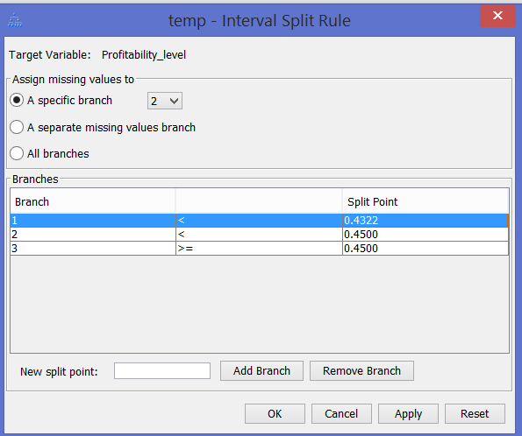

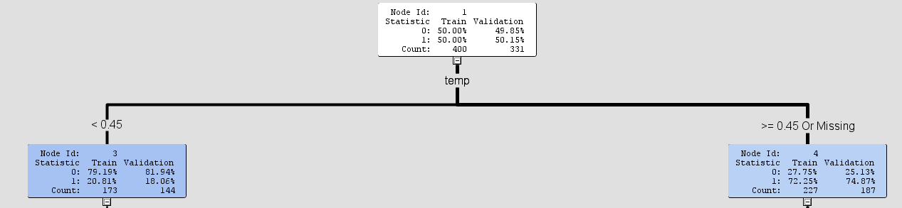

1. After selecting the lower left node (temp) in a new *Split Node*, we selected season, which ranks second in logworth. This split created two leaves

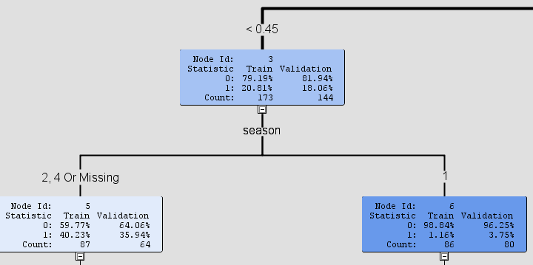

1. After selecting the lower right node (temp) in a new *Split Node*, we manually split the node based on the attribute, hum.

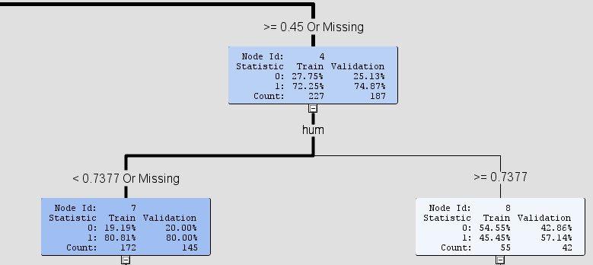

1. After further continuing this method to split a few nodes, we trained the tree using Train Node option and the tree formed is shown below:

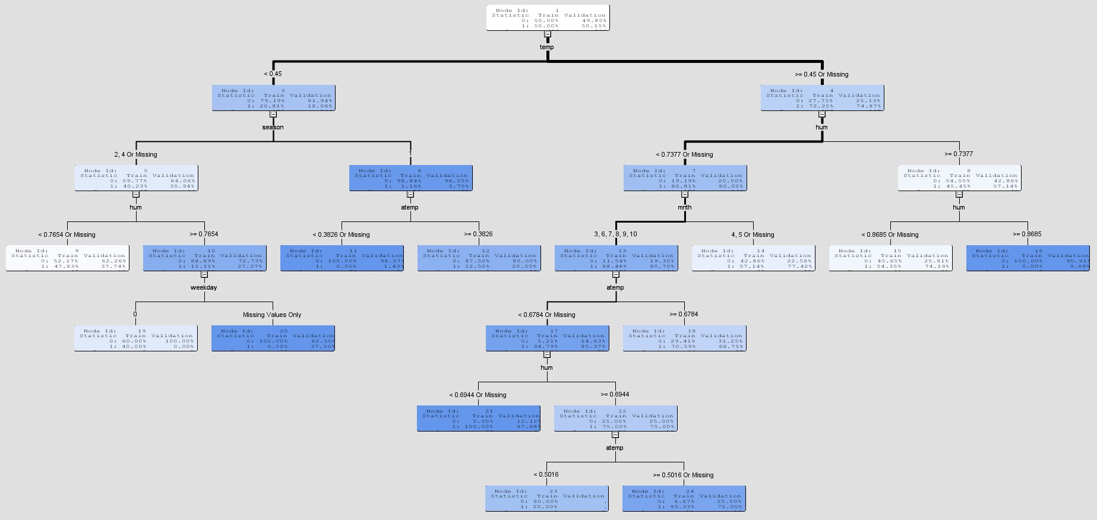

1. We closed the interactive window and changed the *Use Frozen Tree* property from No to Yes so as to prevent the tree from changing by any other property setting when the process is run. The tree node was executed.

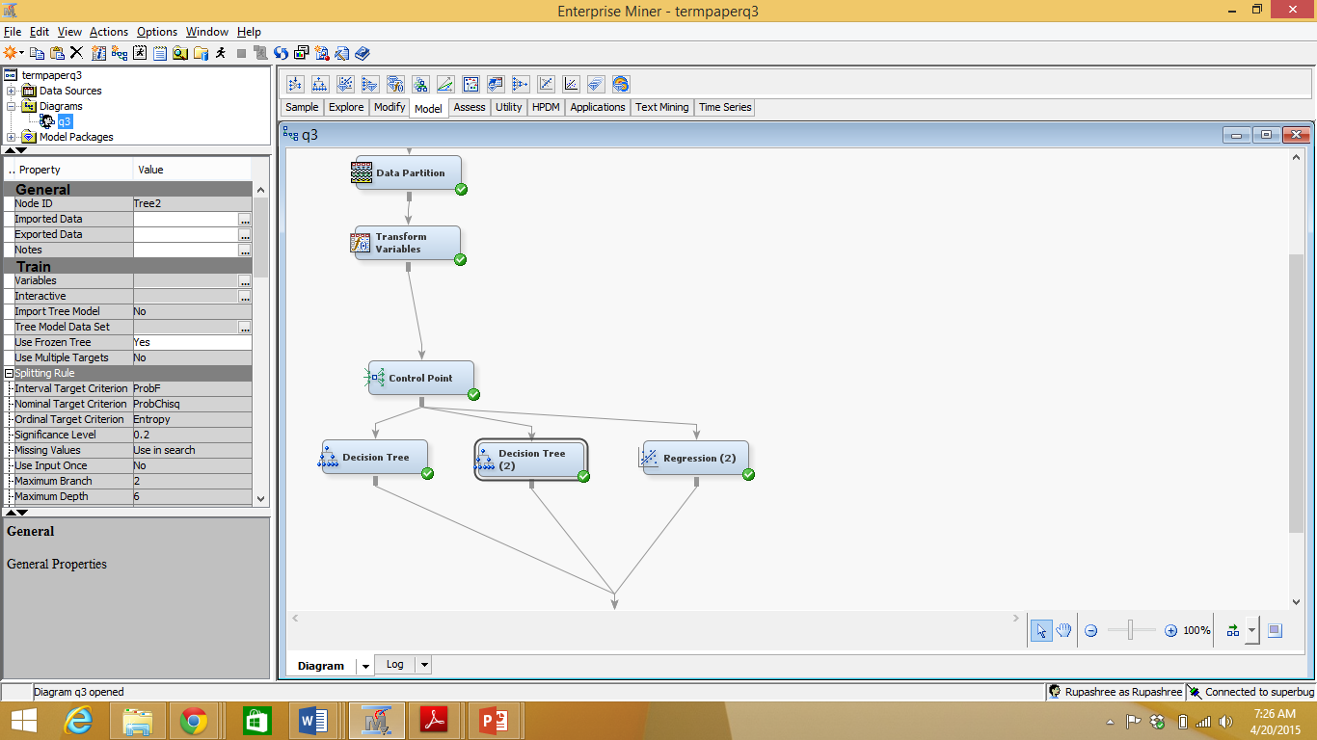

**Output**

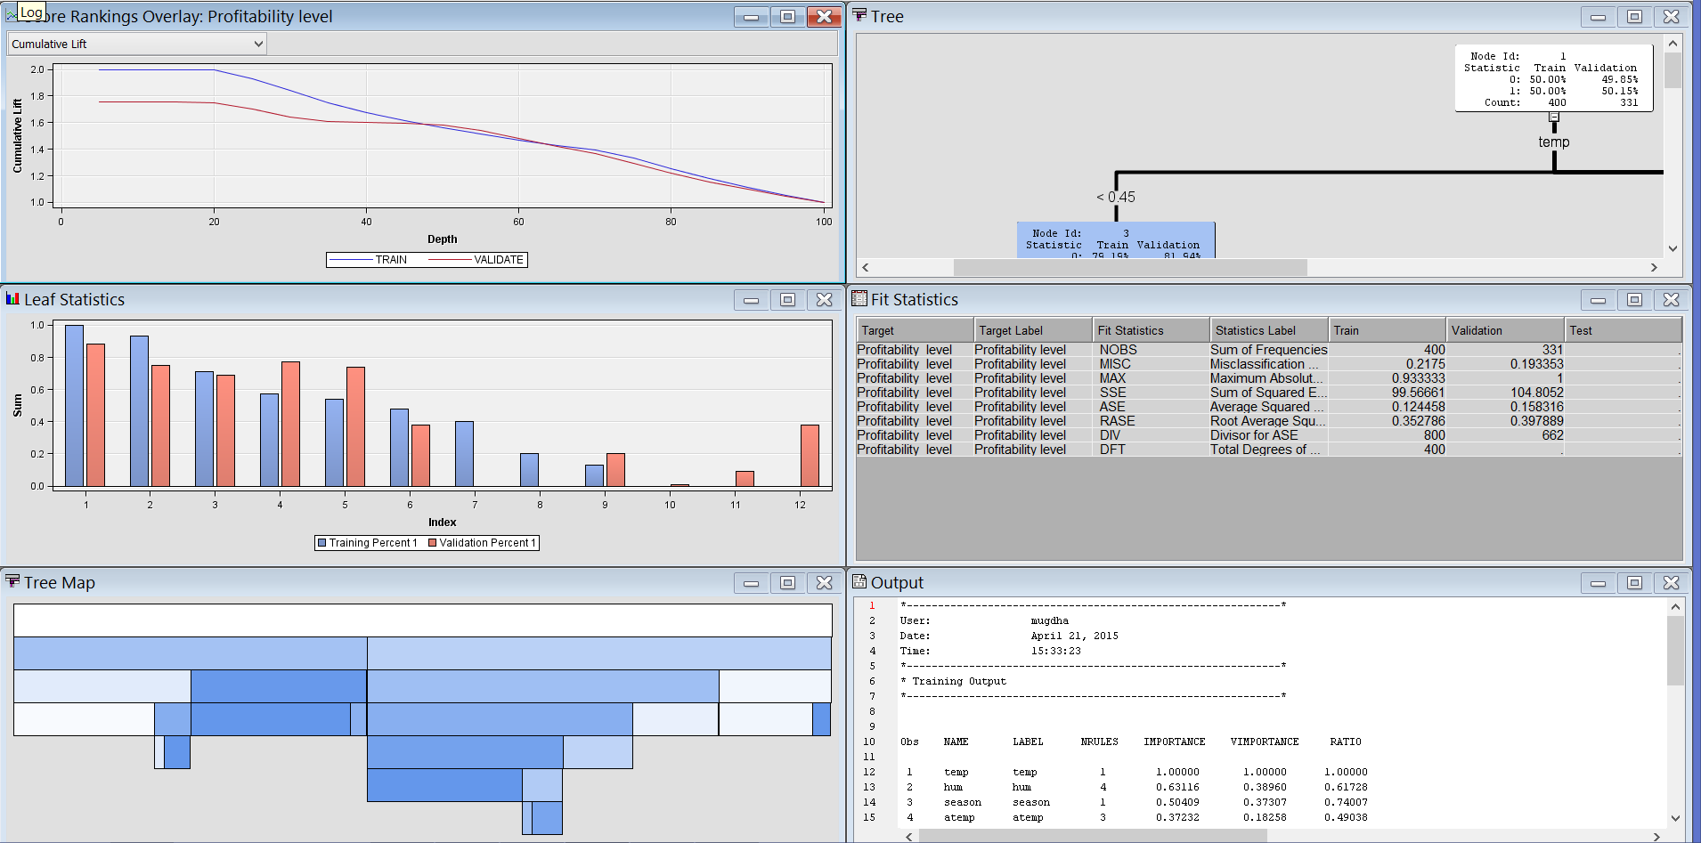

**Output Interpretation:**

The decision tree is a classification tool which we have employed to predict the profitability level. We are trying to find whether given certain input parameters, a particular day will be profitable or not. We have divided the dataset into training and validation data. Training data is used for building the model and the validation dataset is used to select the best model and fine tune the parameters used. Using the interactive decision tree we can create a tree interactively based on the logworth of the input variables and split the tree by editing conditions to meet our analysis requirements.

The target we have kept for predictive modelling using Decision tree is Profitability_level. The *assessment measure* was selected as *decision* which is the default assessment measure. Since the target variable is categorical in nature, the assessment measure selected by default is average square error for the datasets. In the output we observe that the various nodes are split on the variables like temp, season, hum, atemp, month, weekday, transformed variable windspeed. The splits at various nodes create purer subsets and helps in classification of the target variable. We observe that node 11, 16, 19, 20 and node 21 are pure sets and further splits aren’t possible in them. We can observe that the maximal tree created is not the same as the optimal tree. By looking at the tree we can observe the following rules for the tree:

*Node = 9*

*if temp < 0.45 AND season IS ONE OF: 2, 4 or MISSING AND hum < 0.76542 or MISSING, then, Tree Node Identifier = 9*

*Number of Observations = 69*

*Predicted: Profitability_level=1 = 0.48*

*Predicted: Profitability_level=0 = 0.52*

*Node = 11*

*if temp < 0.45 AND season IS ONE OF: 1 AND atemp < 0.3826 or MISSING, then, Tree Node Identifier = 11*

*Number of Observations = 78*

*Predicted: Profitability_level=1 = 0.00*

*Predicted: Profitability_level=0 = 1.00*

*Node = 12*

*if temp < 0.45 AND season IS ONE OF: 1 AND atemp >= 0.3826, then, Tree Node Identifier = 12*

*Number of Observations = 8*

*Predicted: Profitability_level=1 = 0.13*

*Predicted: Profitability_level=0 = 0.88*

*Node = 14*

*if temp >= 0.45 or MISSING AND mnth IS ONE OF: 4, 5 or MISSING AND hum < 0.73771 or MISSING, then, Tree Node Identifier = 14*

*Number of Observations = 42*

*Predicted: Profitability_level=1 = 0.57*

*Predicted: Profitability_level=0 = 0.43*

*Node = 15*

*if temp >= 0.45 or MISSING AND hum < 0.86854 AND hum >= 0.73771 or MISSING, then, Tree Node Identifier = 15*

*Number of Observations = 46*

*Predicted: Profitability_level=1 = 0.54*

*Predicted: Profitability_level=0 = 0.46*

*Node = 16*

*if temp >= 0.45 or MISSING AND hum >= 0.86854, then, Tree Node Identifier = 16*

*Number of Observations = 9*

*Predicted: Profitability_level=1 = 0.00*

*Predicted: Profitability_level=0 = 1.00*

*Node = 18*

*if temp >= 0.45 or MISSING AND mnth IS ONE OF: 3, 6, 7, 8, 9, 10 AND hum < 0.73771 or MISSING AND atemp >= 0.67836, then, Tree Node Identifier = 18*

*Number of Observations = 34*

*Predicted: Profitability_level=1 = 0.71*

*Predicted: Profitability_level=0 = 0.29*

*Node = 19*

*if weekday IS ONE OF: 0 AND temp < 0.45 AND season IS ONE OF: 2, 4 or MISSING AND hum >= 0.76542, then, Tree Node Identifier = 19*

*Number of Observations = 5*

*Predicted: Profitability_level=1 = 0.40*

*Predicted: Profitability_level=0 = 0.60*

*Node = 20*

*if weekday equals Missing AND temp < 0.45 AND season IS ONE OF: 2, 4 or MISSING AND hum >= 0.76542, then, Tree Node Identifier = 20*

*Number of Observations = 13*

*Predicted: Profitability_level=1 = 0.00*

*Predicted: Profitability_level=0 = 1.00*

*Node = 21*

*if temp >= 0.45 or MISSING AND mnth IS ONE OF: 3, 6, 7, 8, 9, 10 AND hum < 0.69438 or MISSING AND atemp < 0.67836 or MISSING, then, Tree Node Identifier = 21*

*Number of Observations = 76*

*Predicted: Profitability_level=1 = 1.00*

*Predicted: Profitability_level=0 = 0.00*

*Node = 23*

*if temp >= 0.45 or MISSING AND mnth IS ONE OF: 3, 6, 7, 8, 9, 10 AND hum < 0.73771 AND hum >= 0.69438 AND atemp < 0.50158, then, Tree Node Identifier = 23*

*Number of Observations = 5*

*Predicted: Profitability_level=1 = 0.20*

*Predicted: Profitability_level=0 = 0.80*

*Node = 24*

*if temp >= 0.45 or MISSING AND mnth IS ONE OF: 3, 6, 7, 8, 9, 10 AND hum < 0.73771 AND hum >= 0.69438 AND atemp < 0.67836 AND atemp >= 0.50158 or MISSING, then, Tree Node Identifier = 24*

*Number of Observations = 15*

*Predicted: Profitability_level=1 = 0.93*

*Predicted: Profitability_level=0 = 0.07*

From the Fit Statistics window, we observe that average square error and misclassification rate for training set is lesser than validation set. The misclassification error is observed to be 0.2175 in the training set and 0.193353 in the validation set. The average square error is 0.124458 in the training set and 0.158316 in the validation set.

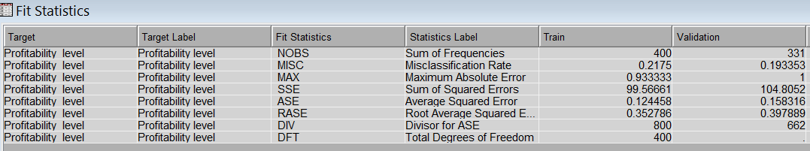

We observed that the average square error has a downward trend. Till the 2nd leaf, the average square error for the training and validation dataset reduces at a steep rate, after which the rate decreases slightly. The rate further reduces after the 3rd leaf. The Average square error in the validation set after the 5th leaf increases slightly which can indicate over-fitting of data with increase in the number of leaves.

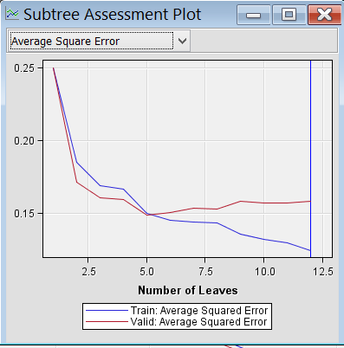

The Leaf statistics graph shows the predicted outcome percentages in the training to the observed outcome percentages in the validation set for each leaf. We can observe that the training data results haven’t reflected very well in the validation dataset.

The cumulative lift graph in the Score ranking overlay window indicates that the records in the first 20 percentiles of the training dataset have a lift value 2.0. The lift value decreases as the predicted probabilities reduces in the remaining percentiles.

From the variable importance window, we can get that

* hum explains 63.12% of the variability in the target variable – profitability level, relative to the 100% variability explained by temp
* season explains 50.41% of the variability in the target variable – profitability level, relative to the 100% variability explained by temp
* atemp explains 37.23% of the variability in the target variable – profitability level, relative to the 100% variability explained by temp
* mnth explains 34.62% of the variability in the target variable – profitability level, relative to the 100% variability explained by temp
* weekday explains 14.91% of the variability in the target variable – profitability level, relative to the 100% variability explained by temp

We can observe that weathersit, workingday and transformed windspeed variables do not explain any variability in the target variable – profitability level, relative to that explained by temp variable.

1. We added the Regression node to the *Control Point* in the process flow which would automatically perform logistic regression as the target variable in this data set is a binary variable.

The binary logistic regression model predicts a binary response based on one or more input variables.

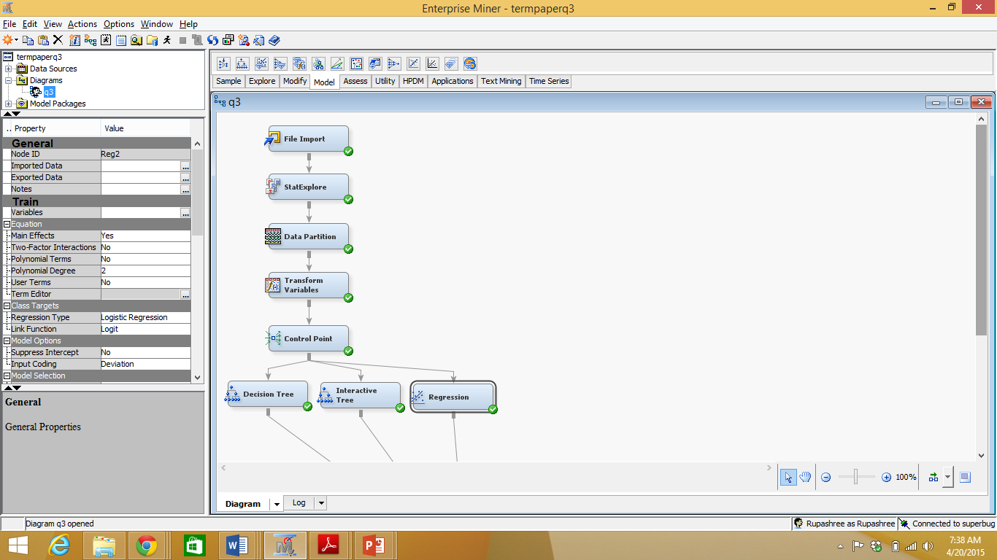

1. We run the node with the default settings.

**Output:**

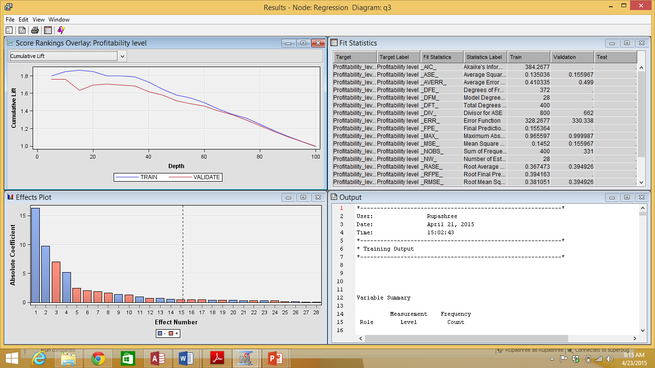

**Output Interpretation:**

On observing the *Output* window from the *Result*:-

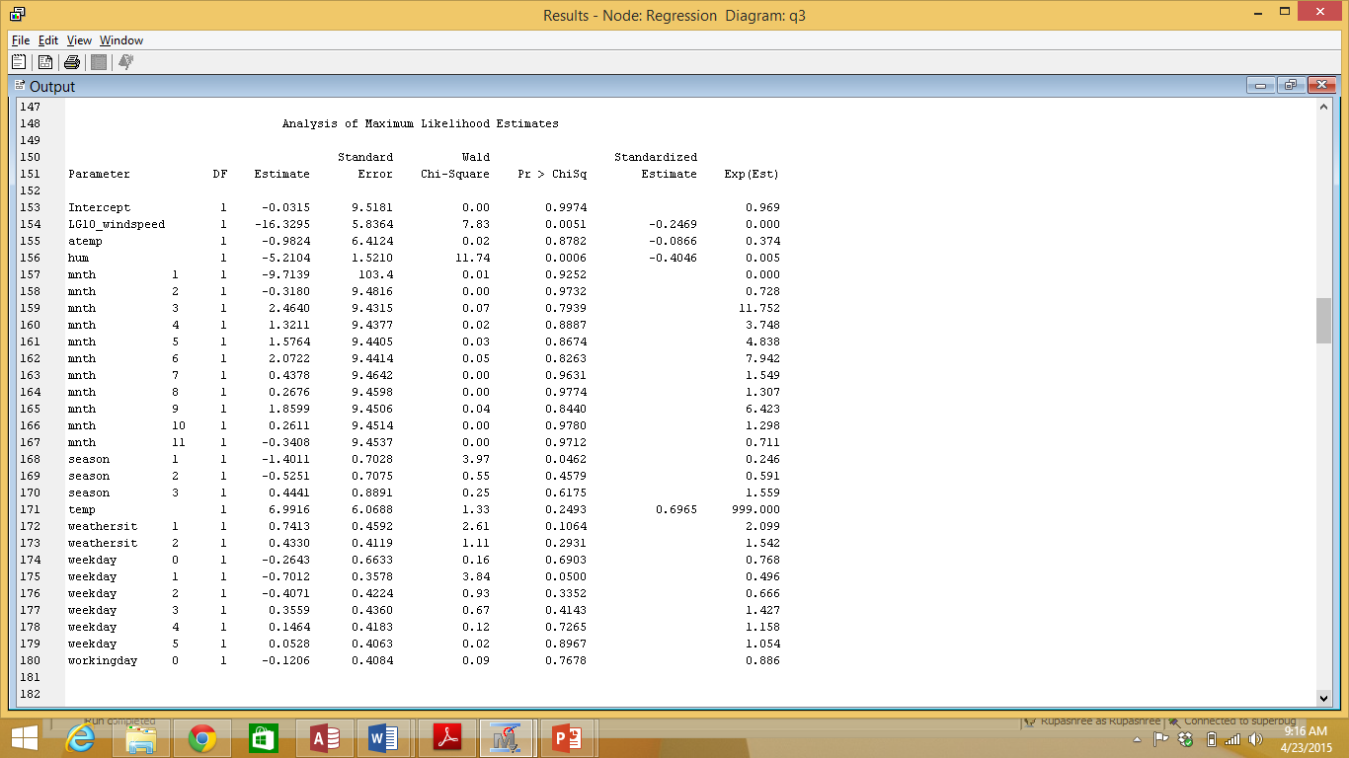

The logit is defined as the log base e of the odds ratio which is the ratio of probability of success to probability of failure. In Logistic Regression the logit can be defined as the linear combination of the input variables :-

ln p/(1-p) = α+βx+e

We can thus define the above output as :-

ln (probability of the day being profitable/ probability of the day not being profitable) = - 0.0315 – 16.3295*Log10_windspeed – 0.9824*atemp + 6.9916*temp – 5.2104*hum -9.7139*mnth(1) w.r.t month(12) - 0.3180*mnth(2) w.r.t month(12) +…….. -1.4011*season(1) w.r.t season(4) - 0.5251* season(2) w.r.t season(4) +…..+ 0.7413*weathersit(1) w.r.t weathersit(3) +….. -0.2643*weekday(0) w.r.t weekday(6)+…… - 0.1206*workingday(0) w.r.t workingday(1)

We can interpret the above equation as:-

* Interval Variables

1 unit change in the temperature, increases the odds ratio by a factor of e^6.9916 = 1087.5

1 unit change in the humidity, decreases the odds ratio by a factor of e^(-5.2104) = 0.005

1 unit change in the atemp, decreases the odds ratio by a factor of e^(– 0.9824) = 0.374

1 unit change in the LOG10_windspeed, decreases the odds ratio by a factor of e^(– 16.3295) = <0.001

* Categorical Variables

Mnth 1 decreases the odds ratio by a factor of 0.00006 with respect to the odds ratio when the mnth is 12; Mnth 2 decreases the odds ratio by a factor of 0.650 with respect to the odds ratio when the mnth is 12 and so on.

Season 1 decreases the odds ratio by a factor of 0.056 with respect to the odds ratio when the season is 4; Season 2 decreases the odds ratio by a factor of 0.134 with respect to the odds ratio when the season is 4 and so on.

Weathersit 1 increases the odds ratio by a factor of 6.791 with respect to the odds ratio when the weathersit is 3; Weathersit 2 increases the odds ratio by a factor of 4.989 with respect to the odds ratio when the weathersit is 3 and so on.

Weekday 0 decreases the odds ratio by a factor of 0.339 with respect to the odds ratio when the Weekday is 6 and so on.

Workingday 0 decreases the odds ratio by a factor of 0.786 with respect to the odds ratio when the Workingday is 1 and so on.

The above interpretations can also be made by observing the *Odds Ratio Estimate* section in the *Output* window.

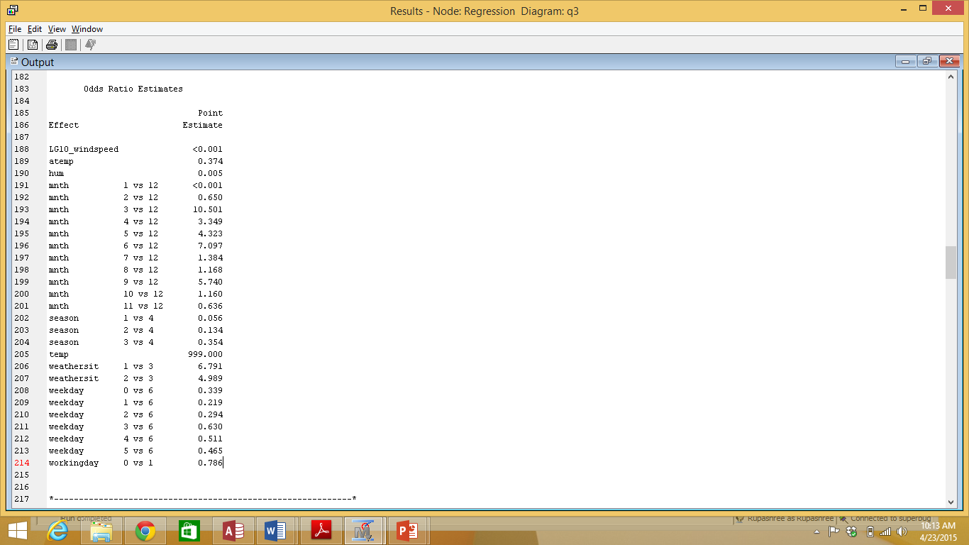

We thus observe that temp has the greatest effect on the odds ratio i.e. for 1 unit change in the temperature, the odds ratio changes by the largest margin and LG10_windspeed has the least effect on the odds ratio. We also observe that out of the mnths, mnth 3 increases the odds ratio the most. Out of all the seasons, season 4 increases the odds ratio the most. Out of all weathersits, weathersit 1 increases the odds ratio the most. Out of the weekdays, weekday 6 increases the odds ratio the most.

We also observed the *Cumulative Lift Ratio* which shows the improvement that the Logistic Regression model provides for both Training and Validation data over the situation when no model was used:-

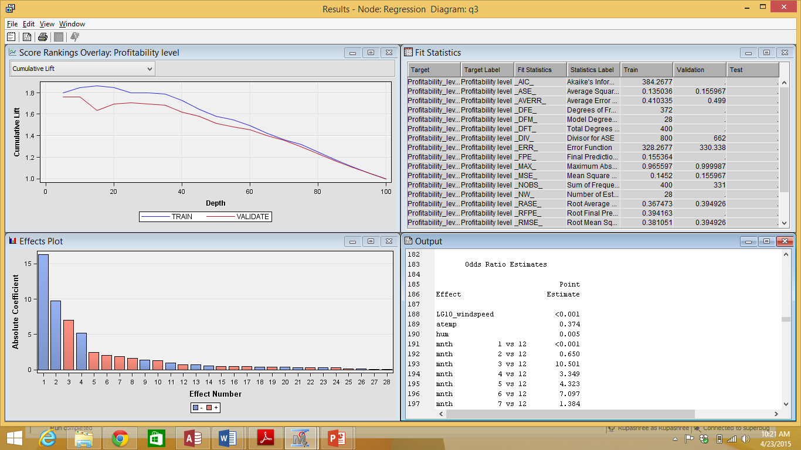

1. Since we now have 3 candidate models to use for prediction, namely Optimal Tree, Interactive tree and Logistic Regression, we can compare them to determine a champion model that can be used to score new data. We added the Model Comparison Node to the process flow to compare the 3 models.

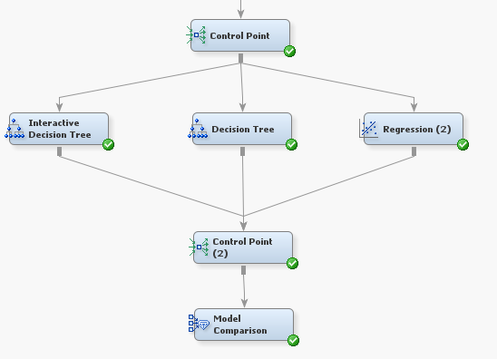

1. As we had decided the model assessment criterion to be Average Squared Error, we set the *Selection Statistic* in the *Model Selection* property and the *Selection Table* property of the *Model Comparison* node to be *Average Squared Error* and *Validation* respectively.

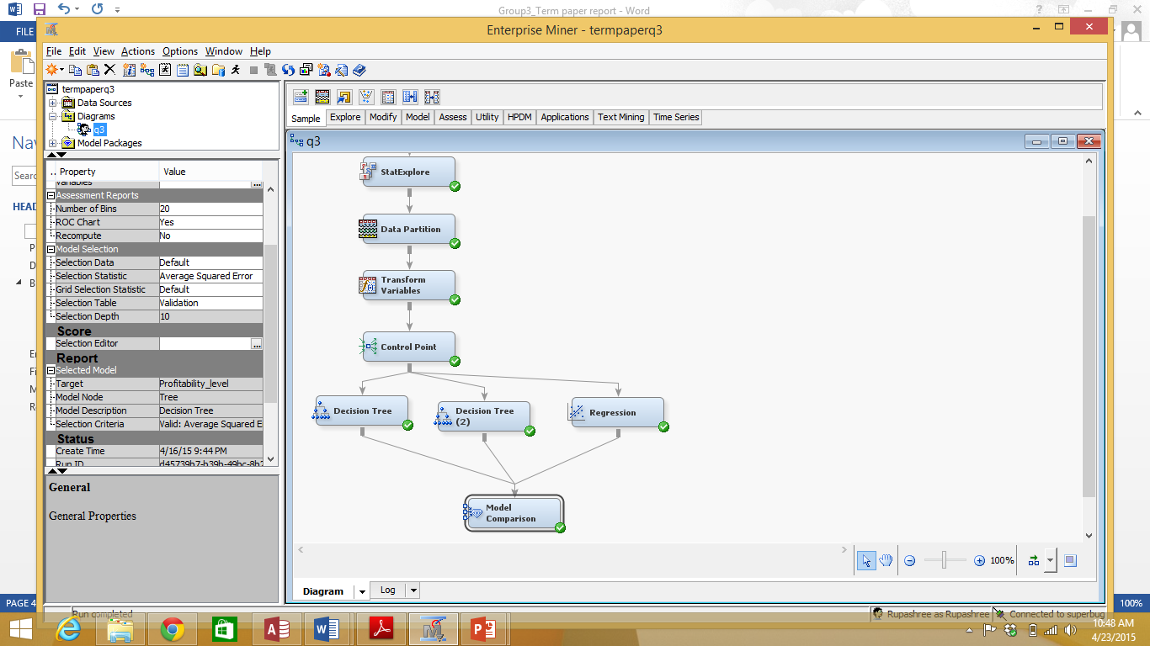

1. The Model Comparison node is run

**Output:**

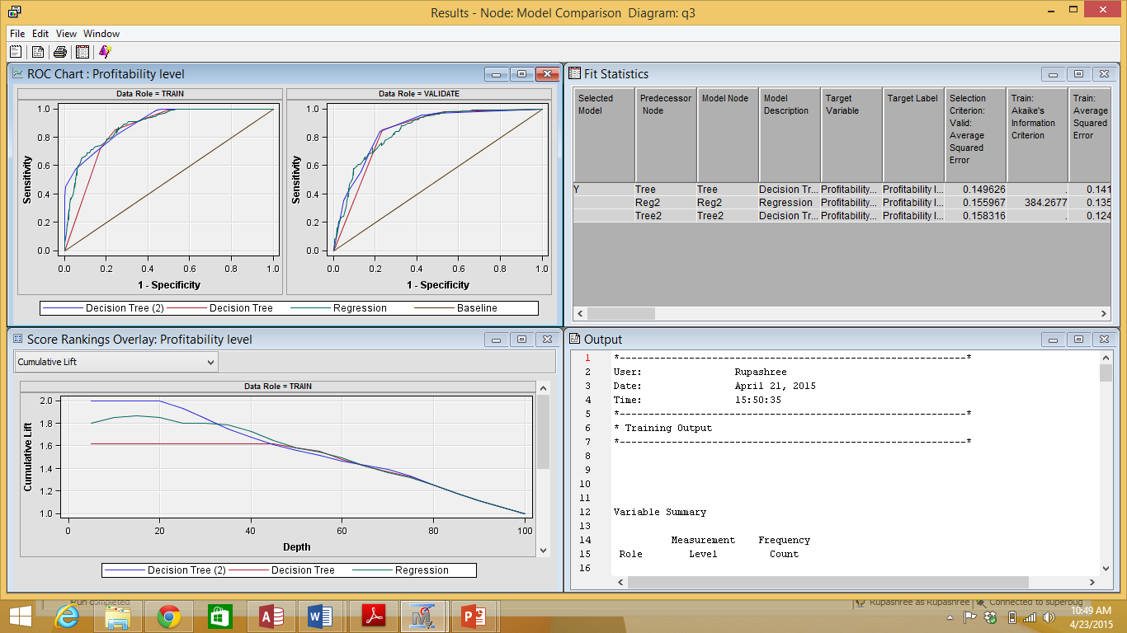

**Output Interpretation:**

After the Node was executed, the fit statistics window shows that the Model Comparison node has selected Optimal Decision Tree as the champion model as indicated by the value **Y** in the *Selected Model* column.

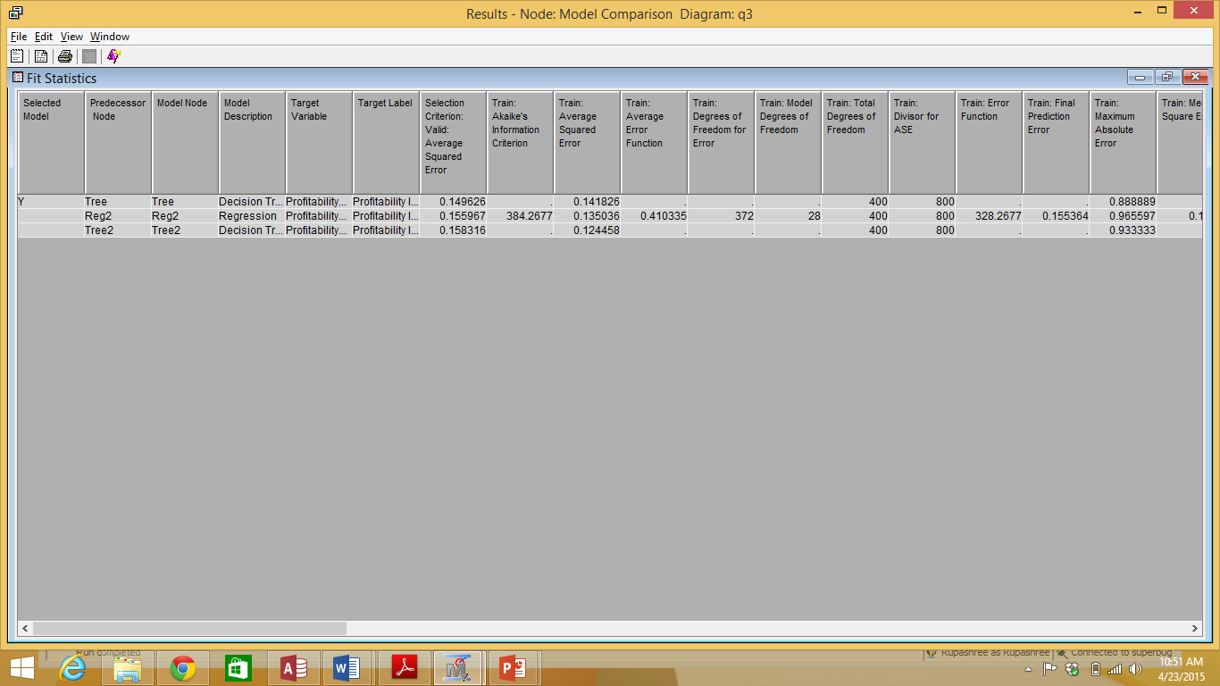

# 

# **Enterprise Miner Diagrams:-**

WORKFLOW 1: MULTIPLE LINEAR REGRESSION

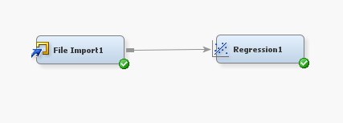

WORKFLOW 2: CLUSTERING

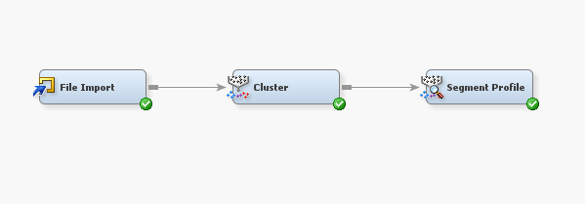

WORKFLOW 3: PREDICTIVE MODELLING

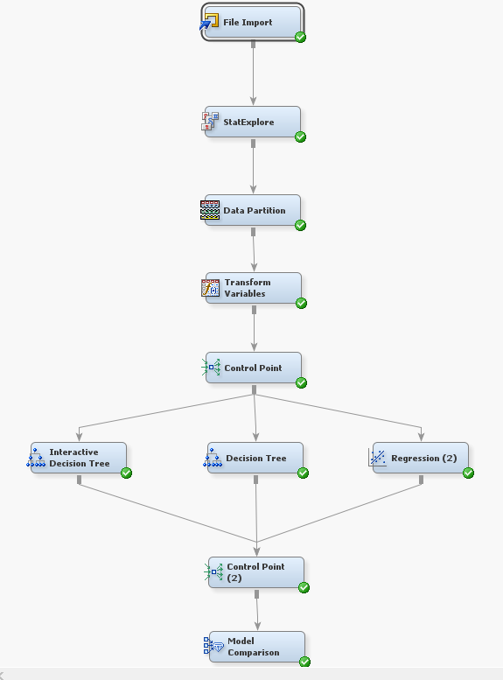

# **Findings:-**

Following are the findings and the conclusions drawn from each of the data mining techniques that we have used on the data set in this project:-

* **Multiple Linear Regression**

The Linear regression technique was applied to find whether weather conditions play a role in the renting behavior of the casual and registered users on a given day. The purpose was to compare the renting behaviors of these 2 different kinds of users so that the bike-sharing company/system can formulate targeted strategy to attract these 2 types of users.

33.25% of variability in the number of casual users and 35.13% of variability in the number of registered users is explained by the weather conditions. A good proportion of the remaining variability in the number of casual and registered users respectively would be explained by the other factors listed in the dataset like season, day of the week, whether the given day is a holiday etc. We also considered that all data contain a natural amount of variability that is unexplainable by the regression equation i.e. the given inputs, and are caused due to various uncertainties. Considering all these factors, in a real world application, 33.25% and 35.13% are substantially high R sq values for the weather conditions and it can inferred that the renting behavior of the users are explained by the weather conditions to a substantial extent.

From this analysis, we can conclude that there is a similarity in the renting behavior of registered and casual users with respect to the weather conditions on any given day, in terms of the effect the weather parameters in total, have on the numbers of users renting bikes. Also the usage of bikes by both casual and registered users is positively correlated to temperature and feel temperature and negatively correlated to humidity and wind speed. However the usage of bikes by registered users is most influenced by feeling temperature followed by wind speed, humidity and then actual temperature. Whereas the usage of bikes by casual users is most influenced by feeling temperature followed by actual temperature, wind speed and then humidity. We thus observed that the casual users are more influenced by actual temperature than the registered users.

* **Clustering**

On applying Clustering technique on the data containing the weather parameters; namely actual temperature, feeling temperature, humidity and wind-speed we got 6 clusters. By studying the distribution of the input variables in each of the clusters through segment profiling, we observed the dominant weather parameters in each of the clusters and named the clusters accordingly.

* Cluster 1 – Seattle Gloom
* Cluster 2 - Tropical Sun
* Cluster 3 - Chicago Summers
* Cluster 4 - Wild West Texas
* Cluster 5 - Boston Freeze
* Cluster 6 - The Big Ben

By observing the profitability level in each of the 6 clusters, we can infer that certain weather conditions are more likely to be profitable for the Bike sharing company/system than others.

|  |  |  |
| --- | --- | --- |
| **Cluster** | **Cluster** | **Profitability Level** |
| 1 | Seattle Gloom | Lower than average |
| 2 | Tropical Sun | Average |
| 3 | Chicago Summers | Higher than average |
| 4 | Wild West Texas | Higher than average |
| 5 | Boston Freeze | Average |
| 6 | The Big Ben | Lower than average |

Thus a combination of high temperature, low humidity and high or low wind-speed is most favorable for bike-renting, whereas a combination of low or average temperature, high humidity and low wind-speed is least favorable for bike-renting.

* **Predictive Modeling:**

**Optimal Decision Tree**

With the decision tree model, we are trying to find answers to the question whether a given day, based on factors like environmental parameters, whether it is a working day or a holiday etc will be profitable for the company or not. The purpose was to formulate strategies based on the input variables and determine how important they are, in determining the profitability.

The assessment measure used was average squared error and we created an optimal tree based on the same. SAS EM automatically prunes and trains the root node to get the best tree based on the least average square error criteria. We observe that the average square error is lesser in training set than in validation set, which is expected. The lift value of 1.6 tells us that the records in the first 50 percentiles are 60% more likely to be profitable than any record which is randomly selected from the data.

From this Decision tree analysis, we can also conclude that temperature, humidity, feel temperature, transformed variable windspeed, month of the day and season are the most significant factors affecting the profitability on a given day. Using this information the company can probably formulate schemes for casual and registered users based on favorable/unfavorable weather conditions to increase revenue.

**Interactive Decision Tree**

We created a decision tree interactively and we are trying to find answers to the question whether a given day, based on factors like weather conditions, whether it is a working day or a holiday etc will be profitable for the company or not. The purpose was to formulate strategies based on the input variables and determine how important they are in determining the profitability of a given day.

The assessment measure used by SAS EM was decision and we could create a tree based on this criteria. Based on the logworth, the nodes in the tree are split and purer subsets are formed. We split the tree as per our requirement and also edited conditions for branching. We observed that the average square error is lesser in training set than in validation set. The lift value of 2.0 for the training data tells us that the records in the first 20 percentiles are 100% more likely to be profitable than any record which is randomly selected from the dataset.

From this Interactive Decision tree analysis, we can conclude that temperature, feel temperature, season, humidity, month of the day and the day of the week are the most significant factors affecting the profitability on a given day. Using this information the company can probably formulate schemes for casual and registered users based on favorable/unfavorable weather conditions to increase revenue. The company can implement schemes specific to season to attract more customers.

**Logistic Regression**

By applying the logistic regression technique on the dataset, we tried to predict the profitability level of a given day – profitable or not profitable, based on all environmental and seasonal details and other relevant information about the day. Logistic Regression predicts the occurrence of an event, the day being profitable or not in our case, by calculating its logit i.e. ln(Probability of the day having ‘Good Business’/ Probability of the day not having ‘Good Business’) as a linear combination of all the input variables.

From the output of the logistic Regression, we observed that as the temperature variable has the highest co-efficient i.e. for 1 unit change in temperature the odds ratio i.e. the ratio of probability of the day being ‘profitable’ to the probability of the day not being ‘profitable’ increases by a factor of 1087.5. Thus out of the weather situation, the probability of a day being profitable is most affected by temperature, followed by feel temperature, humidity and then wind speed, keeping all other factors constant. From the co-efficients, we also inferred that if the given day falls in the 3rd month, the odds ratio increases by the maximum margin compared to that of the other months and hence 3rd month is the most favorable for the business to have profit. By similar observation we can infer that 1st month is least favorable for the business. Season 4 i.e. winter and weather situation 1 i.e. Clear, Few clouds, Partly cloudy are most favorable for the bike renting business.

**Champion Model**

When we applied the Model Comparison node to the process flow, the Optimal Tree was selected as the Champion Model. As Average Squared Error of the Validation Data was selected as the model assessment criteria, the optimal decision tree was considered the best because it has the lowest Average Squared Error for validation 0.149626 compared to the Average Squared Error of the Logistic Regression and Interactive Decision Tree which are 0.155967 and 0.158316 respectively.

Thus it can be concluded that out of the total 3 models, the Optimal Decision Tree as a predictive model, works best for the Bike-sharing dataset.

# **Managerial Implications**

The idea behind doing data mining for bike sharing data was to find factors that affect the renting of bikes and ways to improve business. The objective was to find whether, weather and seasonal conditions affected the profitability, and whether the different types of users exhibited trends in their renting pattern etc. The main purpose was to find potential factors and adjustable filters based on weather parameters and user types which will help maximize the profitability.

From our findings in the linear multiple regression model, we found that registered and casual users have positive correlation with temperature. Thus a bike-share company can use this fact to its advantage and formulate certain schemes which will potentially increase the revenue on days on which the temperature is higher or lower than average.

* On days which have higher than average temperature, water bottles can be provided to all users to cope with the heat and high humidity and thus ensuring a better customer experience.
* Free caps can be provided on days which are sunnier than average and have higher temperature and higher windspeed.
* When the temperatures are low and are not favorable for biking, helmets can be rented for free to casual users as an added attraction to rent bikes.
* On days which have temperatures that are unfavorable for bike renting, discounts can be provided to casual bike renters to promote business. Lower hourly bike rent rates will prompt many people to use the service despite the not-so-favorable climatic conditions.

From clustering, we found two combinations which are favorable and unfavorable for bike renting respectively.

* Combination of high temperature (both actual and feel), low humidity and high or low wind-speed is most favorable for bike-renting. Hence it can be ensured that during such climatic conditions, each bike stand has more bikes available for renting. Water bottles, wet-wipes (tissue boxes) and caps can also be provided for sale at the stands to beat the heat.
* Combination of low or average temperature, high humidity and low wind-speed is least favorable for bike-renting. As an added attraction to boost renting in these conditions raincoats can be provided to users because when the temperature is low and the humidity is high it is likely to rain. Rental umbrellas can also be provided to registered users, which the users can pick up at the bike stand when they drop off their bikes.

From the predictive modelling techniques we tried to find that given certain conditions, whether a day would be profitable or not. Temperature, humidity and month are the most important factors in predicting the profitability of the day.

* Since we have noted that the 3rd month of the year and the winter season have high probability of being profitable, discounts and promotional offers can be provided during these months to attract more customers.
* In the month of March (3rd month) Spring-mini biking marathons can be planned to promote business and get more people aware of biking as a mode of transportation.
* As the month of January is not favorable for business, hot coffee can be provided to casual and registered users as an added incentive to the customers to rent bikes.
* As weather situation 1 i.e. when the weather is clear, few clouds or partly cloudy, is very favorable for bike renting, the sale of jerseys or hoodies as bike riding accessories can be promoted during these weather conditions.

Apart from the above schemes we can also try to reach out different kinds of users with the help of social media like Facebook, Twitter, Instagram etc.

* We can have lucky draws/contests for people who check-in on Facebook at the bike stands or tweet about the bike renting experience or Instagram their photos with the rented bikes.
* We can involve users by tracking their usage data and awarding them points for every mile they have travelled on the bike. We can help them build a healthy lifestyle by encouraging users to reach a certain mile and provide them a free goodie when they do so. This will help increase customer loyalty and retention.
* We can provide advertisements and posts on social media about the different schemes/promotional offers to reach out to existing users and attract new users to rent bikes.
* We can provide biking gears (helmets, riding goggles, jerseys, bottles etc) for discounted prices for registered users
* We can have special events for children, adults or senior citizens to target different audiences.

# **References:-**

<https://archive.ics.uci.edu/ml/datasets/Bike+Sharing+Dataset>

<http://blog.minitab.com/blog/adventures-in-statistics/regression-analysis-how-do-i-interpret-r-squared-and-assess-the-goodness-of-fit>

<http://blog.minitab.com/blog/adventures-in-statistics/multiple-regession-analysis-use-adjusted-r-squared-and-predicted-r-squared-to-include-the-correct-number-of-variables>

<http://support.sas.com/documentation/cdl/en/emgsj/66018/PDF/default/emgsj.pdf>

<http://www.peopleforbikes.org/blog/entry/infographic-bike-sharing-sweeps-the-u.s>

<http://www.nctr.usf.edu/jpt/pdf/JPT12-4DeMaio.pdf>

<http://associationsnow.com/2014/09/biking-booming-bike-share-industry-gets-association/>

<http://www.ats.ucla.edu/stat/sas/faq/oratio.htm>

<http://www.ats.ucla.edu/stat/sas/output/sas_logit_output.htm>

Getting Started with SAS® Enterprise Miner™ 13.1

SAS Enterprise Miner Help